**Internet Programming – Team project**

Name: foodoDeliciouso

Motto: Just Do IT

Github link: <https://github.com/iuthub/ip-group-project-just-do-it>

Web Site: restaurantproject.uz

Members:

Tursunov Davronbek U1810147

Kodirov Tokhirjon U1810163

Jamshid Tursunov U1810153

Shahzod Buriev U1810084

Zufarov Sardor U1810172

Ulugbek Ulugbekov U1810192

**Brief Description about company**

We have designed web site for restaurant called foodoDeliciouso. We have implemented all necessary features for restaurant web site. This restaurant provides all European and National foods. Also it has many different type of drinks and desserts. It is big restaurant which has many tables for customers in it. There work cashiers, people who control all process and waiters. Our web site includes features such as Booking Table that can be used booking table before hand, Delivery Food which takes order from customer and shows it to admin, Online Menu and feedback for customers. Also, admin can add other admins, see feedbacks, booked tables, orders for food, add food, modify any kind of food details and delete food. By this information, restaurant can manage its work properly and faster.

**Screenshots and implementation of functionalities.**

**Our main page looks as follows:**

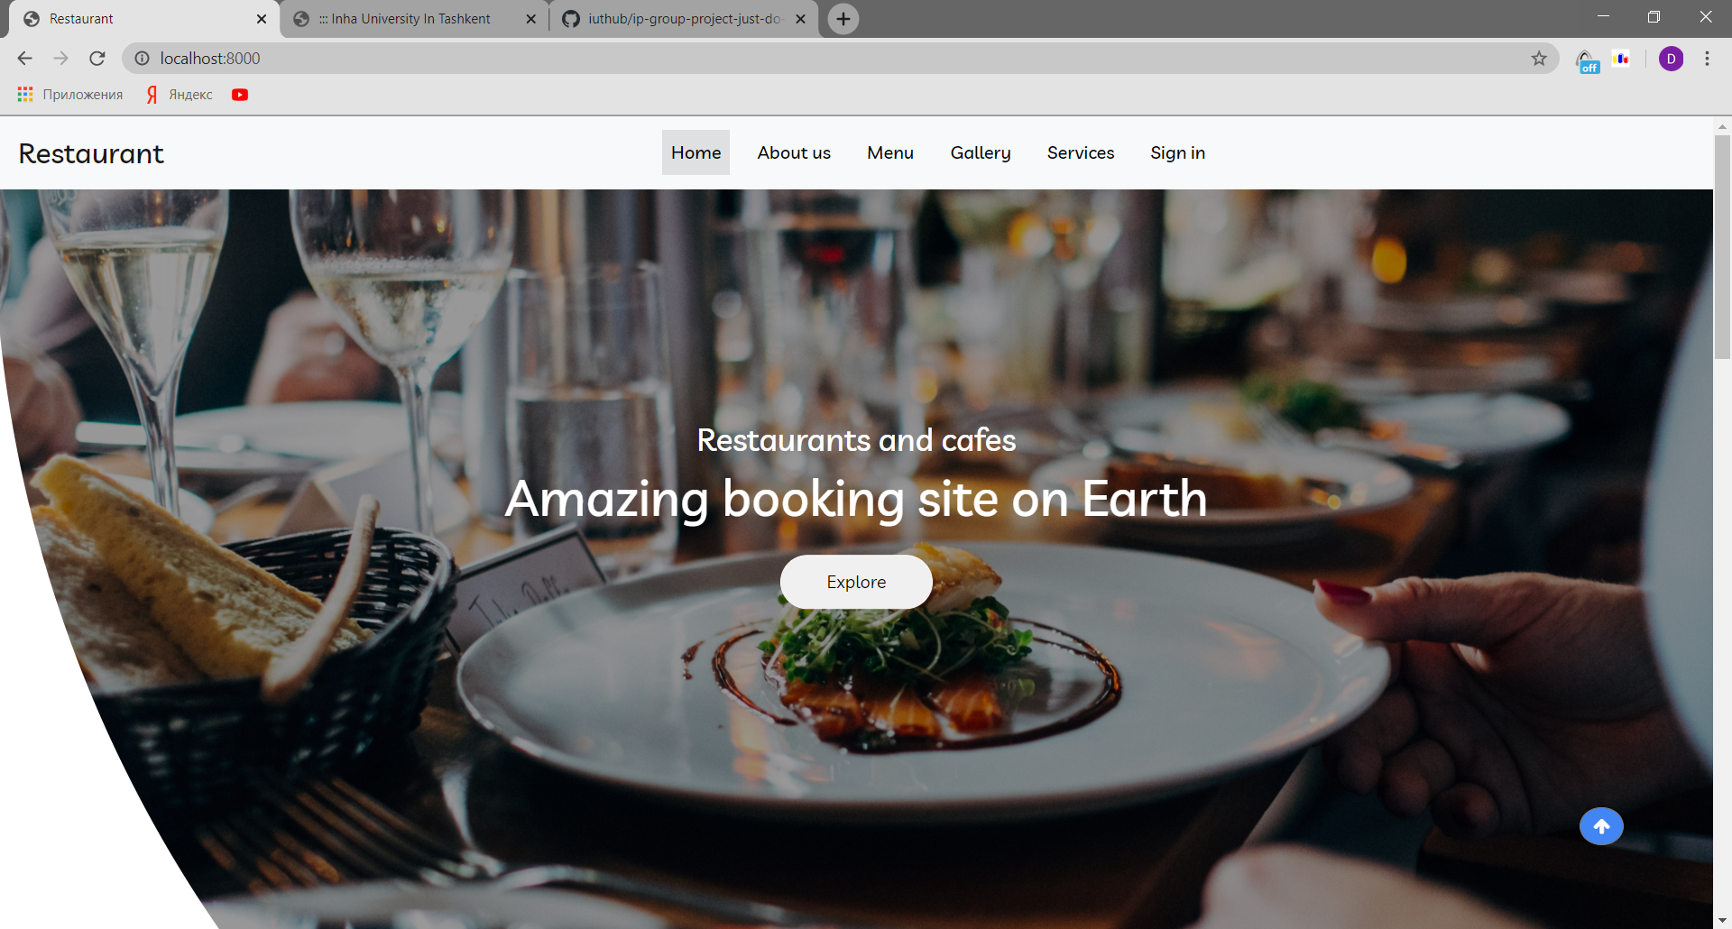

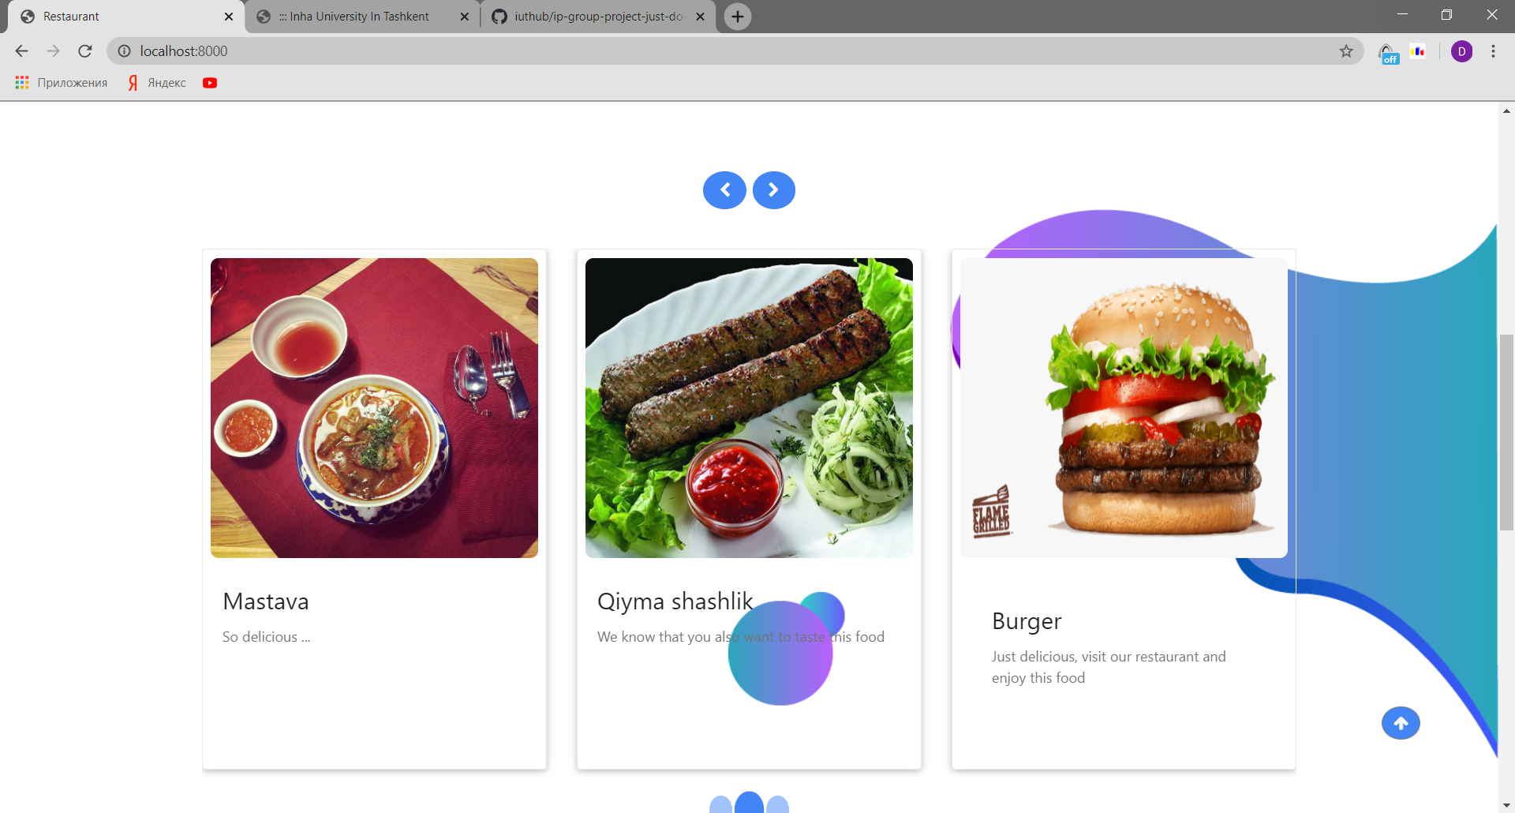

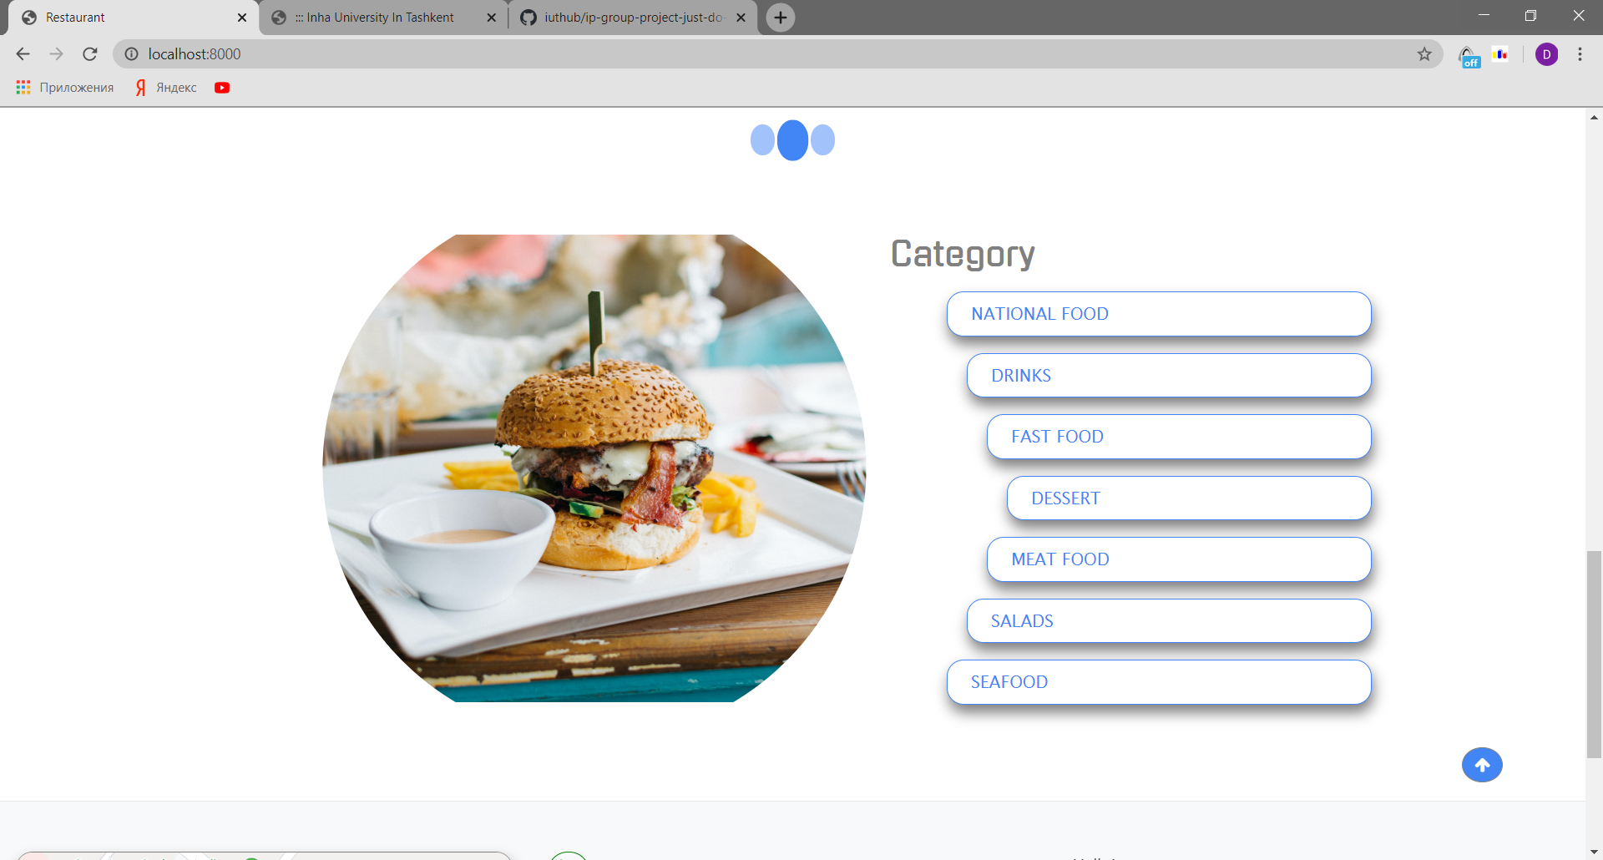

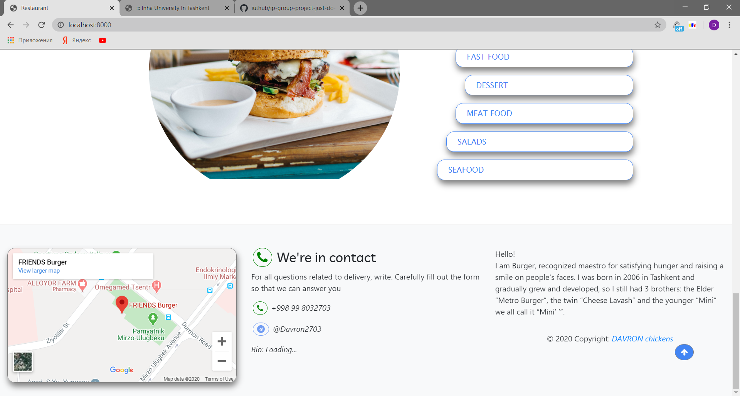

Implementation:

1.So starting from the navbar:



We almost used bootstrap for our project as It provides us with responsivity and site quality. Navbar consists of main buttons which have their own functionality to route the pages when the client clicks. Bootstrap helped us construct our navbar part. It is in views->partials->navbar.blade.php folder

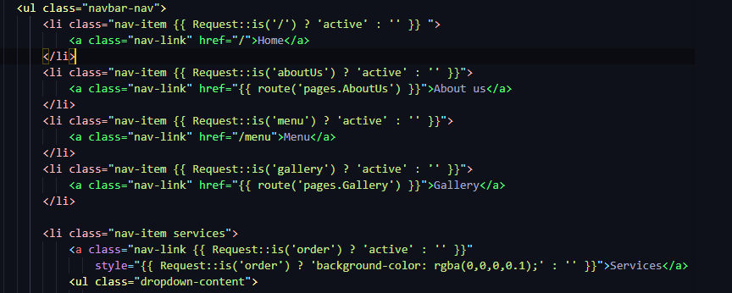

2. Our web site shows that after navbar there is a body part of our main home page. It was decorated with the code clip path for cutting left site image. Then at right side on bottom we decided to fix a button which helps the user to get the top of the page when it is clicked. For this button we used jQuery library of JavaScript. This folder is located in views->partials->body.blade.php

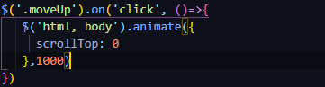 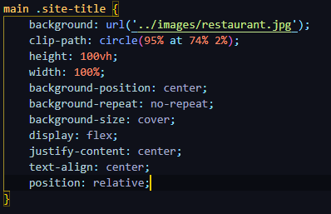



3.Carousel*

For this part of the home page, as we preferred to use carousel for advertising our company’s products. We used bootstrap carousel for it



It is very flexible and provides several kinds of food for clients. When the user clicks next or not, it will automatically move right. It shows different foods from database with it is specific photo. If user changes any data related to this foods it will automatically appear in this place too.

4.Categories. Finally, categories.

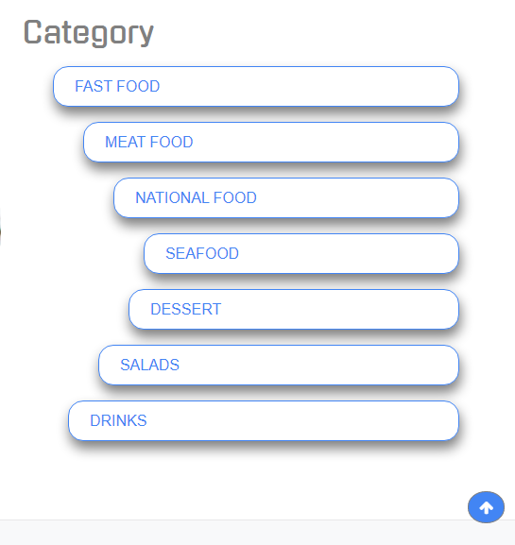 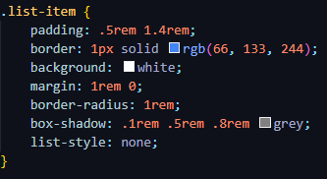

They are all not at the same width. Because we have preferred them to perform circle shape. However, when the screen gets on mobile version, they are going to be shaped with the same width shape. This categories are taken from database and if admins adds new category for food or deletes that will appear here too.

5.Footer

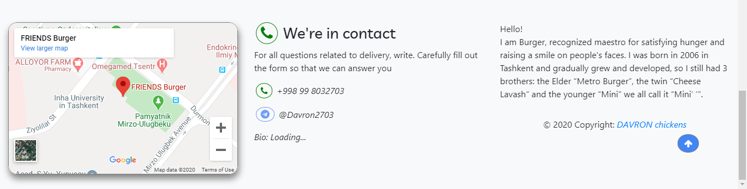

Footer consists of 3 fractions: google map, contact of our staff and about info of Burger. We have used bootstrap for footer to divide them into 3 parts.

Also all user pages including admin pages shows errors and info like this:



**Menu Page:**

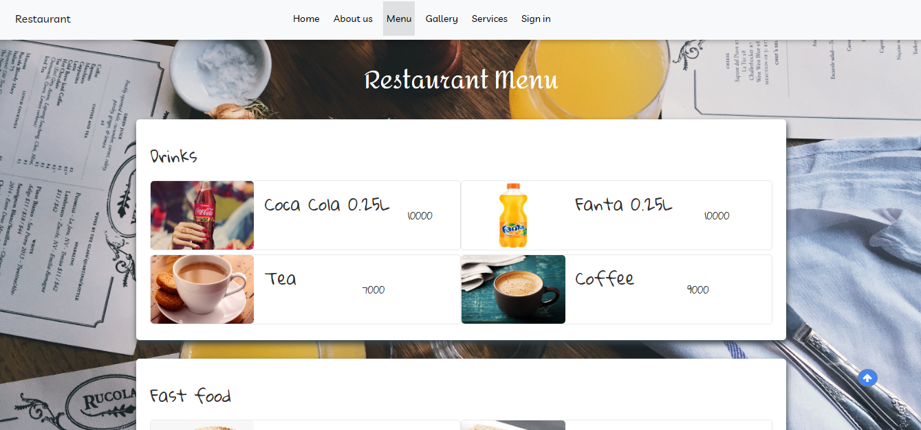 We have styled our page using CSS and 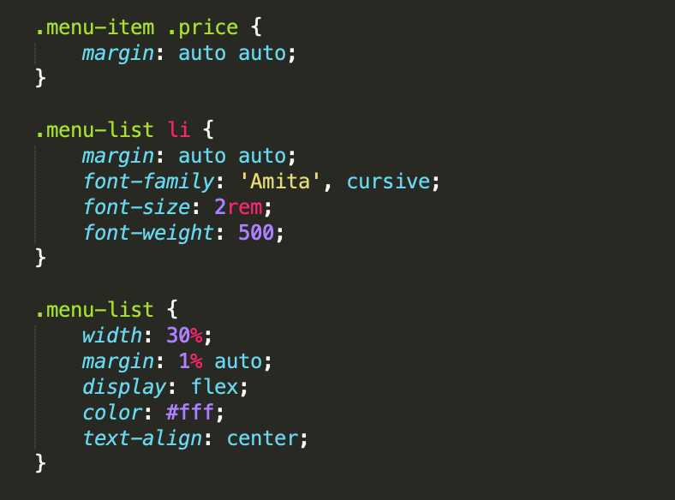bootstrap. It gives us flexibility, so. we just was able to change websites appearance without making significant changes on the main files. We can observe that menu page is managed by sections of category foods. Each Category of food is separate section of the page. Within the section there are cards of appropriate item of foods which has image of the food, name and price.

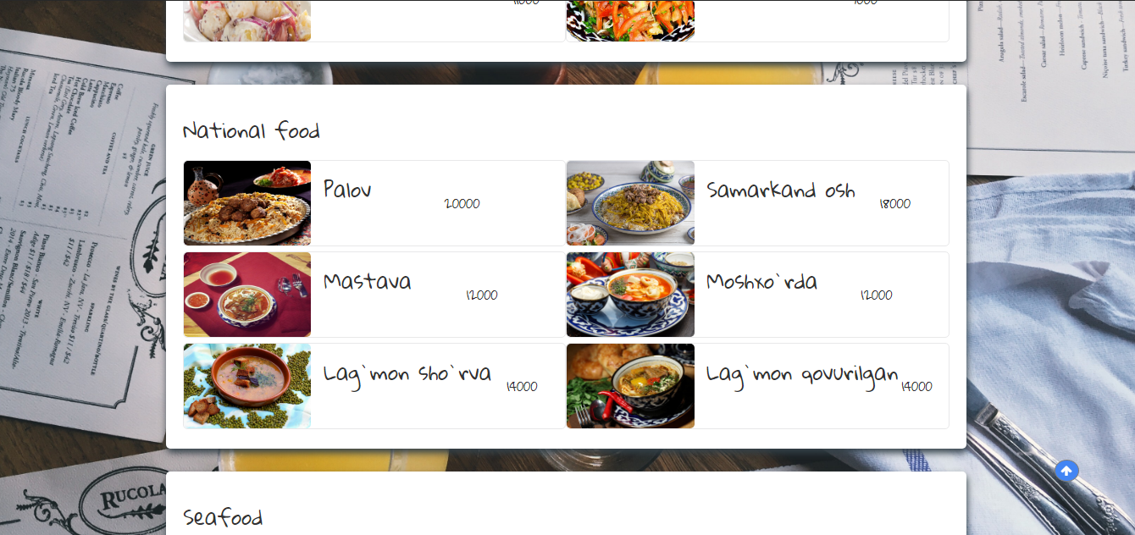

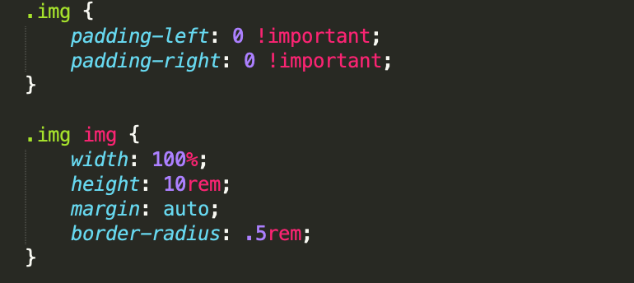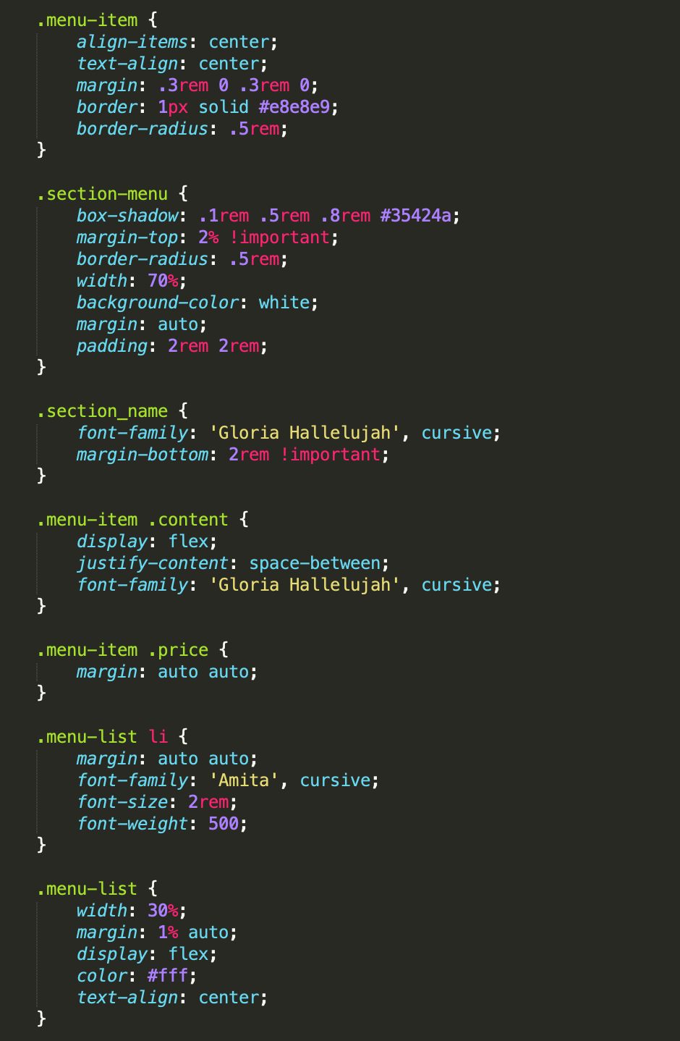

So section has its own properties. Also sections are built to be flexible. Each section can adopt according to number of item and information it has. Tasks like adding a new food, category or delete a foot, category or just changing particular data is accomplished without any issues as each section is adaptive on its own.

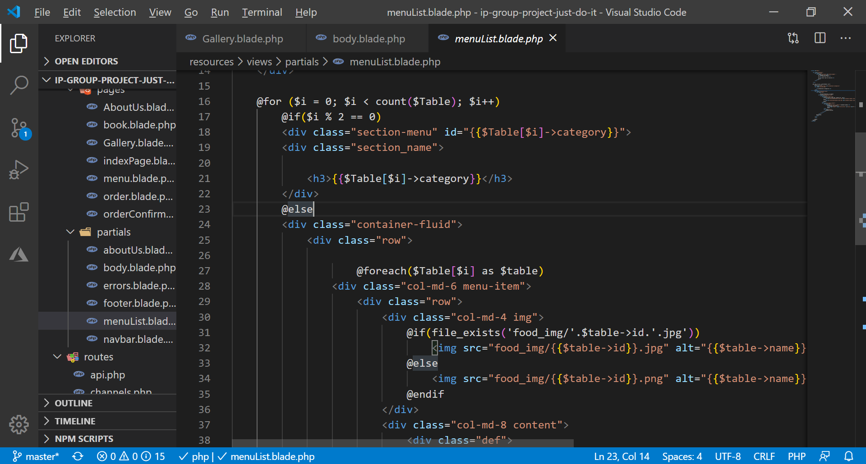

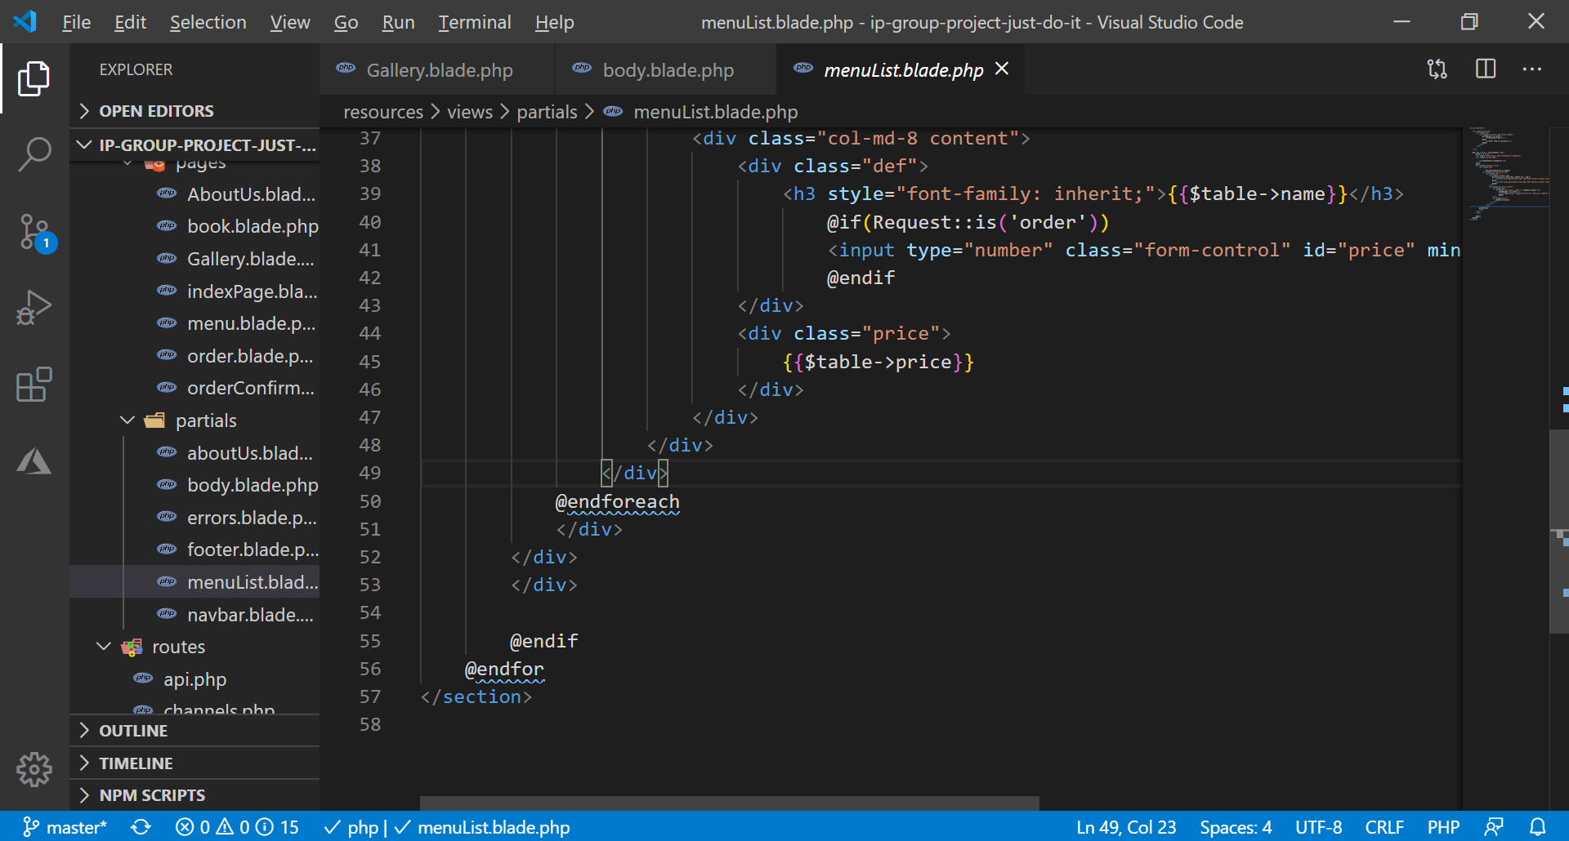

This code shows that our menu is dynamic. It gets date from controllers and show it here. Admin changes to food details can automatically affected to here too. It takes all images from public->food_img folder. MenuList.blade.php is located in views->partials folder.

**Services Pages:** 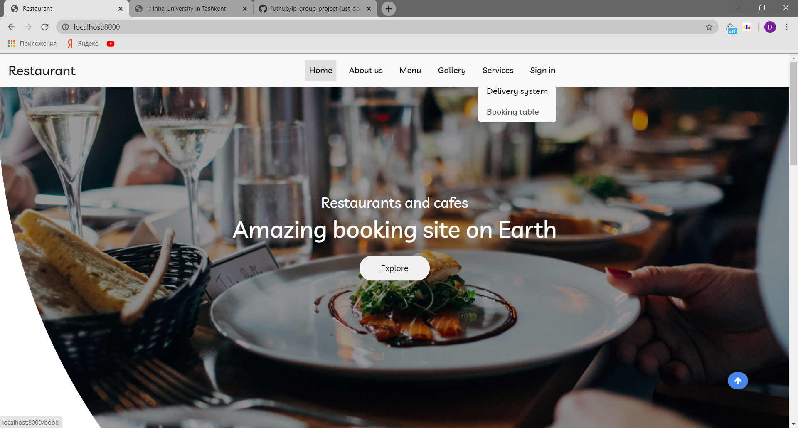

Services pages can be divided into two parts Delivery System and Booking table.

Let’s start with booking sytem models and controller code:

We have created some models, controllers and blade templates. First of all, when it comes to models Book, Comment, PermittedUser and User are created with their tables in DB.

All models

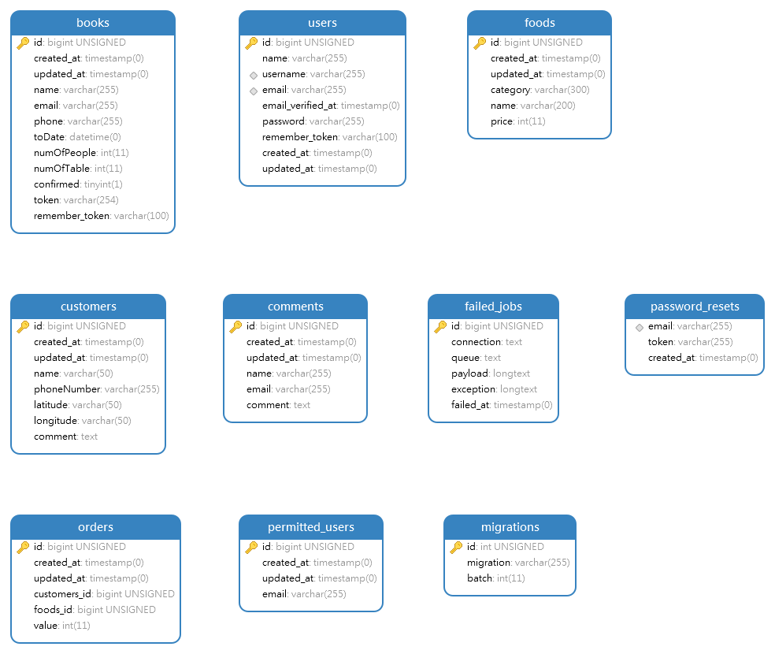

BookController.php

|  |
| --- |
| <?php |
|  |  |
|  | namespace App\Http\Controllers; |
|  |  |
|  | use App\Book; |
|  | use Illuminate\Http\Request; |
|  | use Illuminate\Support\Facades\Date; |
|  | use Illuminate\Support\Facades\DB; |
|  | use Illuminate\Support\Facades\Mail; |
|  | use Illuminate\Support\Facades\Validator; |
|  | use Illuminate\Support\Str; |
|  | use Illuminate\Database\Eloquent\Collection; |
|  |  |
|  |  |
|  | class BookController extends Controller |
|  | { |
|  |  |
|  | public function create(array $data) |
|  | { |
|  | return Book::create([ |
|  | 'name' => $data['name'], |
|  | 'email' => $data['email'], |
|  | 'phone' => $data['phone'], |
|  | 'toDate' => $data['toDate'], |
|  | 'numOfPeople' => $data['numOfPeople'], |
|  | 'numOfTable' => $data['numOfTable'], |
|  | ]); |
|  | } |
|  | }  This function records inputs to the DB. |
|  | public function getBook() |
|  | { |
|  | $books=Book::orderBy('numOfTable', 'asc')->get(); |
|  | $alltable=[]; |
|  | foreach($books as $book) |
|  | { |
|  | array_push($alltable,$book->numOfTable); |
|  | } |
|  | $tables=[]; |
|  | for($i=1;$i<=30;$i++) |
|  | { |
|  | if(in_array($i,$alltable)) $tables[$i]=1; else $tables[$i]=0; |
|  | } |
|  | return view('pages.book', ['tables' => $tables]); |
|  | } |
|  | This function is used to get dynamic form for the booking table. For example, it returns data which includes information about ordered or not ordered table. |
|  | public function postBook(Request $request) |
|  | { |
|  | $input = $request->all(); |
|  |  |
|  | $this->validate($request, [ |
|  | 'name'=>'required|max:255', |
|  | 'email'=>'required|email|max:255', |
|  | 'phone'=>'required|regex:/^\+998[0-9]{9}$/' |
|  | ]); |
|  |  |
|  | $data = $this->create($input)->toArray(); |
|  |  |
|  | $data['token'] =Str::random(50).'_'.time(); |
|  |  |
|  | $book = Book::find($data['id']); |
|  | $book->token = $data['token']; |
|  | $book->save(); |
|  |  |
|  | Mail::send('mail.confirmation', $data, function ($message) use ($data){ |
|  | $message->to($data['email']); |
|  | $message->subject('Booking completed'); |
|  | }); |
|  | return redirect(route('pages.indexPage'))->with([ |
|  | 'data'=>$data, |
|  | 'info'=>'Confirmation email has been sent. Please check your email.' |
|  | ]); |
|  | // } |
|  | // return $validator; |
|  | // return redirect(route('pages.book'))->with('info',$validator->errors()->getMessages()); |
|  | }  This function initially checks validation, if inputs passes it records inputs to the DB and creates unique token in order to confirmation. Then it sends an email with link of confirmation for booked table. |
|  |  |
|  | public function confirmation($token) |
|  | { |
|  | $book=Book::where('token',$token)->first(); |
|  |  |
|  | if(!is_null($book)){ |
|  | $book->confirmed=1; |
|  | $book->token=null; |
|  | $book->save(); |
|  | return redirect(route('pages.indexPage'))->with('info','Your activation is completed.'); |
|  | } |
|  | return redirect(route('pages.indexPage'))->with('info','Something went wrong.'); |
|  | } |
|  |  |
|  | public function getAdminIndex() |
|  | { |
|  | $books=Book::orderBy('updated_at', 'desc')->paginate(10); |
|  | return view('admin.index', ['books' => $books,'i'=>1]); |
|  | } |
|  |  |
|  | public function getAdminDelete($id) |
|  | { |
|  | $book = Book::find($id); |
|  | $book->delete(); |
|  | return redirect()->route('admin.index')->with('info', 'Booking deleted!'); |
|  | } |
|  |  |
|  | public function postSearchBook(Request $request) |
|  | { |
|  |  |
|  | $name=$request->input('name'); |
|  | $email=$request->input('email'); |
|  | $phone=$request->input('phone'); |
|  | $toDate=$request->input('toDate'); |
|  | $query=Book::query(); |
|  |  |
|  | if(isset($name)) |
|  | $query->where('name','like','%'.$name.'%'); |
|  | if(isset($email)) |
|  | $query->where('email','like','%'.$email.'%'); |
|  | if(isset($phone)) |
|  | $query->where('phone','like','%'.$phone.'%'); |
|  | if(isset($toDate)) |
|  | $query->where('toDate','like','%'.$toDate.'%'); |
|  |  |
|  | $results=$query->orderBy('updated_at', 'desc')->paginate(10); |
|  |  |
|  | return view('admin.index')->with(['books'=>$results,'i'=>1]); |
|  | } |
|  |  |
|  | }  This function searches according to only entered inputs. |

CommentController.php

|  |
| --- |
| <?php |
|  |  |
|  | namespace App\Http\Controllers; |
|  |  |
|  | use App\Comment; |
|  | use Illuminate\Http\Request; |
|  | use Illuminate\Support\Facades\Mail; |
|  | use Illuminate\Support\Str; |
|  |  |
|  | class CommentController extends Controller |
|  | { |
|  | public function create(array $data) |
|  | { |
|  | return Comment::create([ |
|  | 'name' => $data['name'], |
|  | 'email' => $data['email'], |
|  | 'comment' => $data['comment'] |
|  | ]); |
|  | } |
|  |  |
|  |  |
|  | public function postComment(Request $request) |
|  | { |
|  | $input = $request->all(); |
|  |  |
|  | $this->validate($request, [ |
|  | 'name'=>'required|max:255', |
|  | 'email'=>'required|email|max:255', |
|  | 'comment'=>'required|string|min:10|max:750' |
|  | ]); |
|  |  |
|  | $data = $this->create($input)->toArray(); |
|  |  |
|  | // $data['token'] =Str::random(50).'_'.time(); |
|  | // |
|  | $comment = Comment::find($data['id']); |
|  | // $book->token = $data['token']; |
|  | $comment->save(); |
|  |  |
|  | Mail::send('mail.comment', $data, function ($message) use ($data) { |
|  | $message->to($data['email']); |
|  | $message->subject('Feedback sent'); |
|  | }); |
|  | return redirect(route('pages.indexPage'))->with([ |
|  | 'data'=>$data, |
|  | 'info'=>'Feedback email has been sent. Please check your email.' |
|  | ]); |
|  | } |
|  |  |
|  |  |
|  | public function getAdminIndex() |
|  | { |
|  | $comments=Comment::orderBy('updated_at', 'desc')->paginate(3); |
|  | return view('admin.comment', ['comments' => $comments,'i'=>1]); |
|  | } |
|  |  |
|  | public function getAdminDelete($id) |
|  | { |
|  | $comment = Comment::find($id); |
|  | $comment->delete(); |
|  | return redirect()->route('admin.comment')->with('info', 'Comment deleted!'); |
|  | } |
|  |  |
|  | public function postSearchComment(Request $request) |
|  | { |
|  |  |
|  | $name=$request->input('name'); |
|  | $email=$request->input('email'); |
|  | $comment=$request->input('comment'); |
|  | $query=Comment::query(); |
|  |  |
|  | if(isset($name)) |
|  | $query->where('name','like','%'.$name.'%'); |
|  | if(isset($email)) |
|  | $query->where('email','like','%'.$email.'%'); |
|  | if(isset($comment)) |
|  | $query->where('comment','like','%'.$comment.'%'); |
|  |  |
|  | $results=$query->orderBy('updated_at', 'desc')->paginate(3); |
|  |  |
|  | return view('admin.comment')->with(['comments'=>$results,'i'=>1]); |
|  | } |
|  | }  This function searches according to only entered inputs. |

PermittedUserController.php

|  |
| --- |
| <?php |
|  |  |
|  | namespace App\Http\Controllers; |
|  |  |
|  | use App\Comment; |
|  | use App\PermittedUser; |
|  | use Illuminate\Http\Request; |
|  | use Illuminate\Support\Facades\Mail; |
|  | use Illuminate\Support\Str; |
|  |  |
|  | class PermittedUserController extends Controller |
|  | { |
|  | public function create(array $data) |
|  | { |
|  | return PermittedUser::create([ |
|  | 'email' => $data['email'] |
|  | ]); |
|  | } |
|  |  |
|  |  |
|  | public function postEmail(Request $request) |
|  | { |
|  | $input = $request->all(); |
|  |  |
|  | $this->validate($request, [ |
|  | 'email'=>'required|email|max:255', |
|  | ]); |
|  |  |
|  | $data = $this->create($input)->toArray(); |
|  |  |
|  | $email = PermittedUser::find($data['id']); |
|  | $email->save(); |
|  |  |
|  | // Mail::send('mail.comment', $data, function ($message) use ($data) { |
|  | // $message->to($data['email']); |
|  | // $message->subject('Feedback sent'); |
|  | // }); |
|  | return redirect(route('admin.permitteduser'))->with([ |
|  | // 'data'=>$data, |
|  | 'info'=>'New permitted email has been added' |
|  | ]); |
|  | }  This function is used to add email if input passes validation in order to give this email permission to register |
|  |  |
|  |  |
|  | public function getAdminIndex() |
|  | { |
|  | $email=PermittedUser::orderBy('updated_at', 'desc')->paginate(10); |
|  | return view('admin.permitteduser', ['emails' => $email,'i'=>1]); |
|  | } |
|  |  |
|  | public function getAdminDelete($id) |
|  | { |
|  | $email = PermittedUser::find($id); |
|  | $email->delete(); |
|  | return redirect()->route('admin.permitteduser')->with('info', 'Permitted email deleted!'); |
|  | } |
|  |  |
|  | public function postSearchEmail(Request $request) |
|  | { |
|  |  |
|  | $email=$request->input('email'); |
|  | $query=PermittedUser::query(); |
|  |  |
|  | if(isset($email)) |
|  | $query->where('email','like','%'.$email.'%'); |
|  |  |
|  | $results=$query->orderBy('updated_at', 'desc')->paginate(10); |
|  |  |
|  | return view('admin.permitteduser')->with(['emails'=>$results,'i'=>1]); |
|  | } |
|  | }  This function searches according to only entered inputs. |

Controller.php

|  |
| --- |
| <?php |
|  |  |
|  | namespace App\Http\Controllers; |
|  |  |
|  | use Illuminate\Foundation\Auth\Access\AuthorizesRequests; |
|  | use Illuminate\Foundation\Bus\DispatchesJobs; |
|  | use Illuminate\Foundation\Validation\ValidatesRequests; |
|  | use Illuminate\Routing\Controller as BaseController; |
|  |  |
|  | class Controller extends BaseController |
|  | { |
|  | use AuthorizesRequests, DispatchesJobs, ValidatesRequests; |
|  | }  It is default Laravel Authentication controller. |

LoginController.php

|  |
| --- |
| <?php |
|  |  |
|  | namespace App\Http\Controllers\Auth; |
|  |  |
|  | use App\Http\Controllers\Controller; |
|  | use App\Providers\RouteServiceProvider; |
|  | use Illuminate\Foundation\Auth\AuthenticatesUsers; |
|  | use Illuminate\Http\Request; |
|  | use Illuminate\Http\Response; |
|  | use Illuminate\Support\Facades\Auth; |
|  | use Illuminate\Support\Facades\Cookie; |
|  |  |
|  | class LoginController extends Controller |
|  | { |
|  | /* |
|  | |-------------------------------------------------------------------------- |
|  | | Login Controller |
|  | |-------------------------------------------------------------------------- |
|  | | |
|  | | This controller handles authenticating users for the application and |
|  | | redirecting them to your home screen. The controller uses a trait |
|  | | to conveniently provide its functionality to your applications. |
|  | | |
|  | */ |
|  |  |
|  | use AuthenticatesUsers; |
|  |  |
|  | /** |
|  | * Where to redirect users after login. |
|  | * |
|  | * @var string |
|  | */ |
|  | protected $redirectTo = RouteServiceProvider::HOME; |
|  |  |
|  | /** |
|  | * Create a new controller instance. |
|  | * |
|  | * @return void |
|  | */ |
|  | protected $username; |
|  | public function __construct() |
|  | { |
|  | $this->middleware('guest')->except('logout'); |
|  | $this->username=$this->findUsername(); |
|  | } |
|  |  |
|  | // protected function sendLoginResponse(Request $request) |
|  | // { |
|  | // $customRememberMeTimeInMinutes = 10; |
|  | // $rememberTokenCookieKey = Auth::getRecallerName(); |
|  | // Cookie::queue($rememberTokenCookieKey, Cookie::get($rememberTokenCookieKey), $customRememberMeTimeInMinutes); |
|  | // $request->session()->regenerate(); |
|  | // $this->clearLoginAttempts($request); |
|  | // return $this->authenticated($request, $this->guard()->user()) |
|  | // ?: redirect()->intended($this->redirectPath()); |
|  | // } |
|  |  |
|  | public function findUsername() |
|  | { |
|  | $login=request()->input('login'); |
|  | $fieldType=filter_var($login,FILTER_VALIDATE_EMAIL)?'email':'username'; |
|  | request()->merge([$fieldType=>$login]); |
|  | return $fieldType; |
|  | } |
|  |  |
|  | public function username() |
|  | { |
|  | return $this->username; |
|  | } |
|  |  |
|  |  |
|  | } |

We have added functionality as username. It gives good environment to the admin.

RegisterController.php

|  |
| --- |
| <?php |
|  |  |
|  | namespace App\Http\Controllers\Auth; |
|  |  |
|  | use App\Http\Controllers\Controller; |
|  | use App\PermittedUser; |
|  | use App\Providers\RouteServiceProvider; |
|  | use App\Rules\ValidEmail; |
|  | use App\User; |
|  | use Illuminate\Foundation\Auth\RegistersUsers; |
|  | use Illuminate\Support\Facades\Hash; |
|  | use Illuminate\Support\Facades\Validator; |
|  |  |
|  | class RegisterController extends Controller |
|  | { |
|  | /* |
|  | |-------------------------------------------------------------------------- |
|  | | Register Controller |
|  | |-------------------------------------------------------------------------- |
|  | | |
|  | | This controller handles the registration of new users as well as their |
|  | | validation and creation. By default this controller uses a trait to |
|  | | provide this functionality without requiring any additional code. |
|  | | |
|  | */ |
|  |  |
|  | use RegistersUsers; |
|  |  |
|  | /** |
|  | * Where to redirect users after registration. |
|  | * |
|  | * @var string |
|  | */ |
|  | protected $redirectTo = RouteServiceProvider::HOME; |
|  |  |
|  | /** |
|  | * Create a new controller instance. |
|  | * |
|  | * @return void |
|  | */ |
|  | public function __construct() |
|  | { |
|  | $this->middleware('guest'); |
|  | } |
|  |  |
|  | /** |
|  | * Get a validator for an incoming registration request. |
|  | * |
|  | * @param array $data |
|  | * @return \Illuminate\Contracts\Validation\Validator |
|  | */ |
|  | protected function validator(array $data) |
|  | { |
|  | return Validator::make($data, [ |
|  | 'name' => ['required', 'string', 'max:255'], |
|  | 'username' => ['required', 'string', 'max:255', 'unique:users'], |
|  | 'email' => ['required', 'string', 'email',new ValidEmail(),'max:255', 'unique:users'], |
|  | 'password' => ['required', 'string', 'min:8', 'confirmed'], |
|  | ]); |
|  |  |
|  |  |
|  | } |
|  |  |
|  | /** |
|  | * Create a new user instance after a valid registration. |
|  | * |
|  | * @param array $data |
|  | * @return \App\User |
|  | */ |
|  | protected function create(array $data) |
|  | { |
|  | $email = PermittedUser::where('email', '=', $data['email'])->first(); |
|  | $email->delete(); |
|  |  |
|  | return User::create([ |
|  | 'name' => $data['name'], |
|  | 'username' => $data['username'], |
|  | 'email' => $data['email'], |
|  | 'password' => Hash::make($data['password']), |
|  | ]); |
|  | }  This functions register only permitted emails. |
|  | } |

Let’s continue with Delivery System:

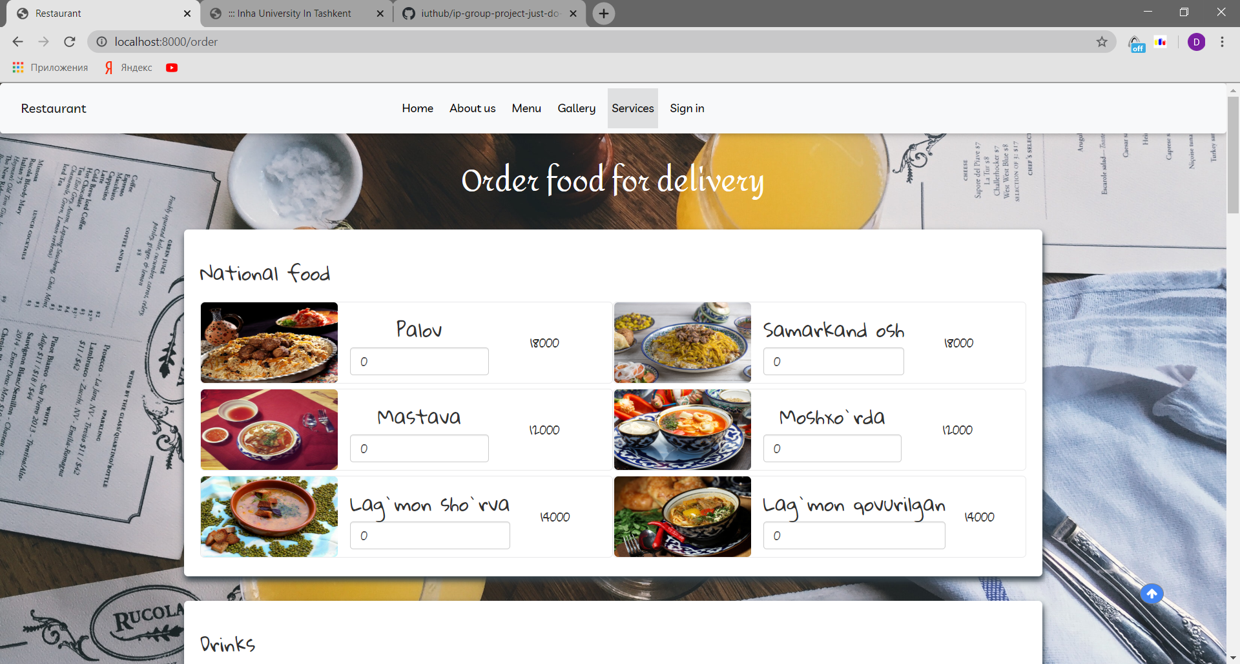

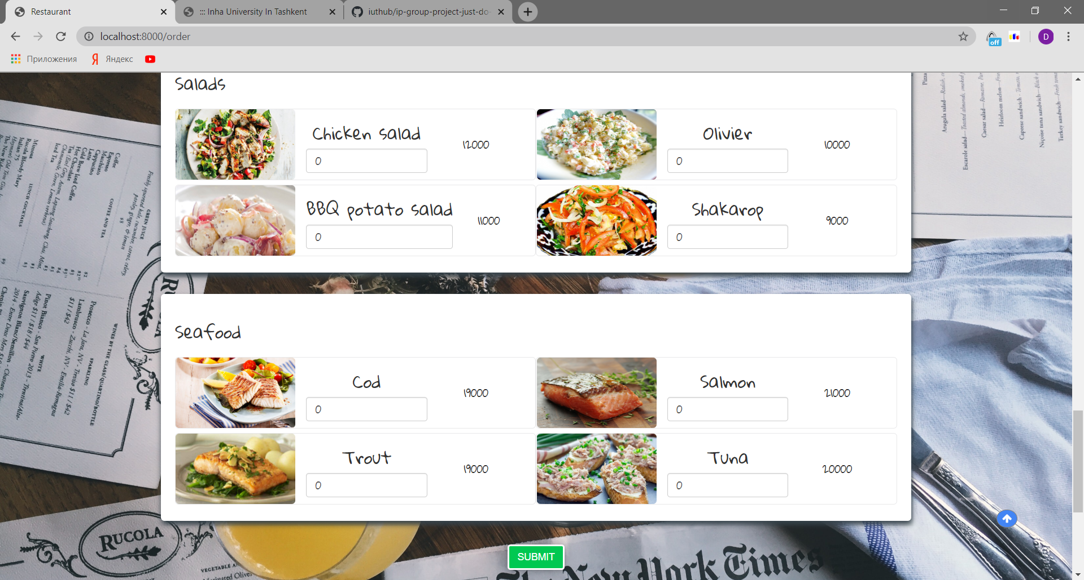

Delivery System page is designed the same as Menu page. If we Submit all inputs as 0 it will give error:

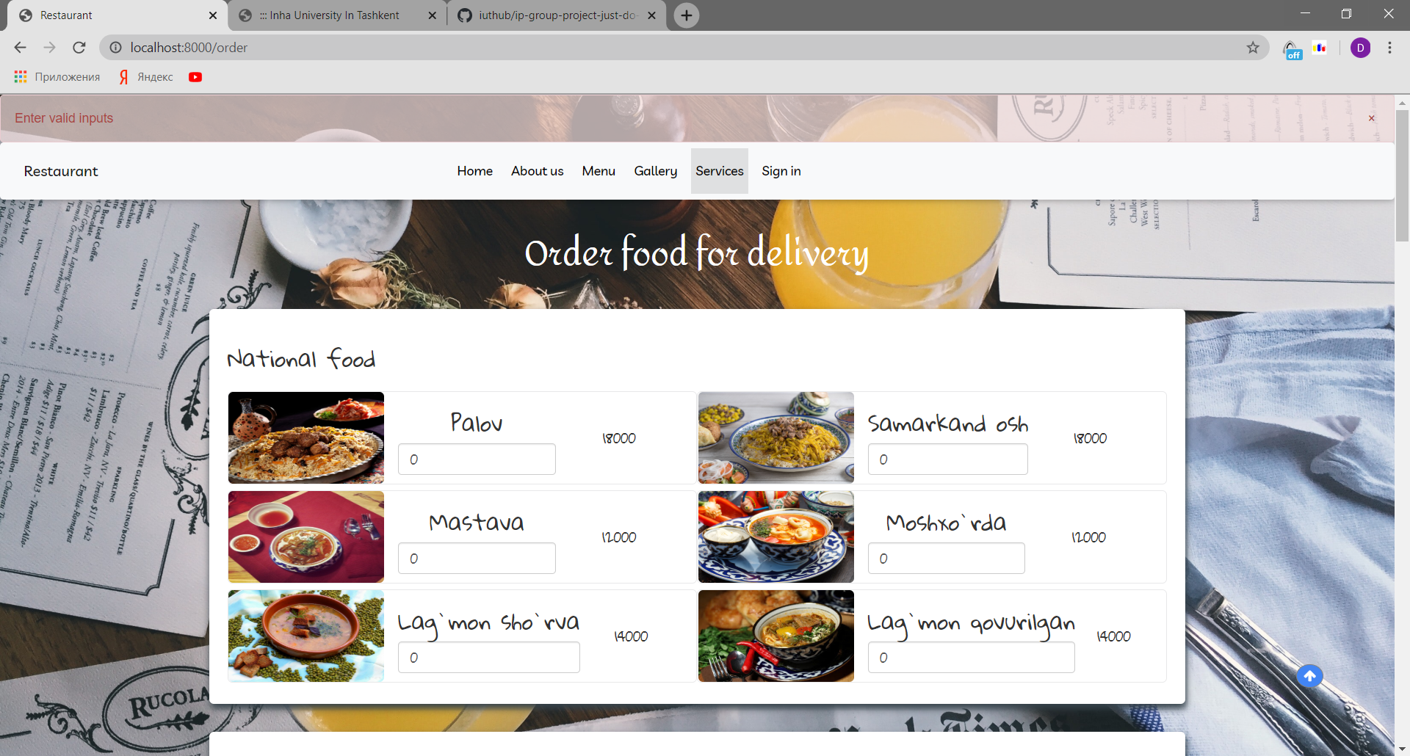

It uses orderSystem Controller to submit and go to next page:

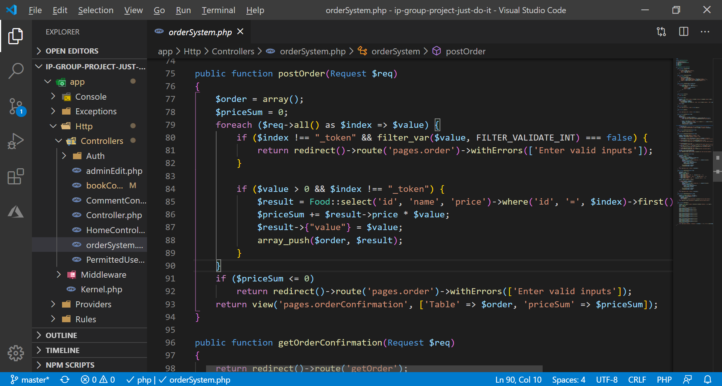

This code calculates total price and adds it to orderConfirmation page with input type=”hidden” method.

After submitting valid inputs it will go to confirmation page. When page loads it takes your Geo location using html geo location API and includes into data. If geo location is turned off from browser, it will ask to turn on using alert() or asks to write comment.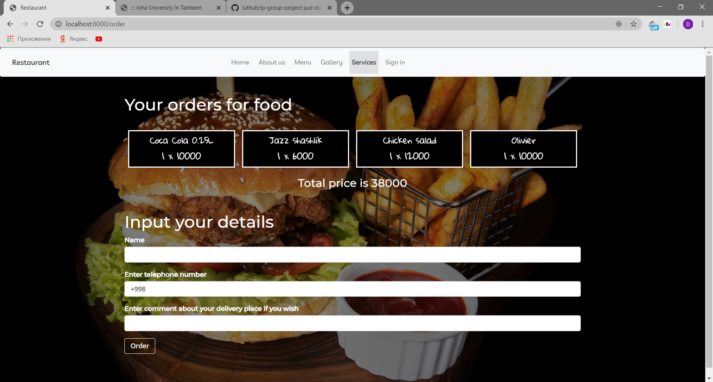

It is validated in user side and the same time at back end side using this code:

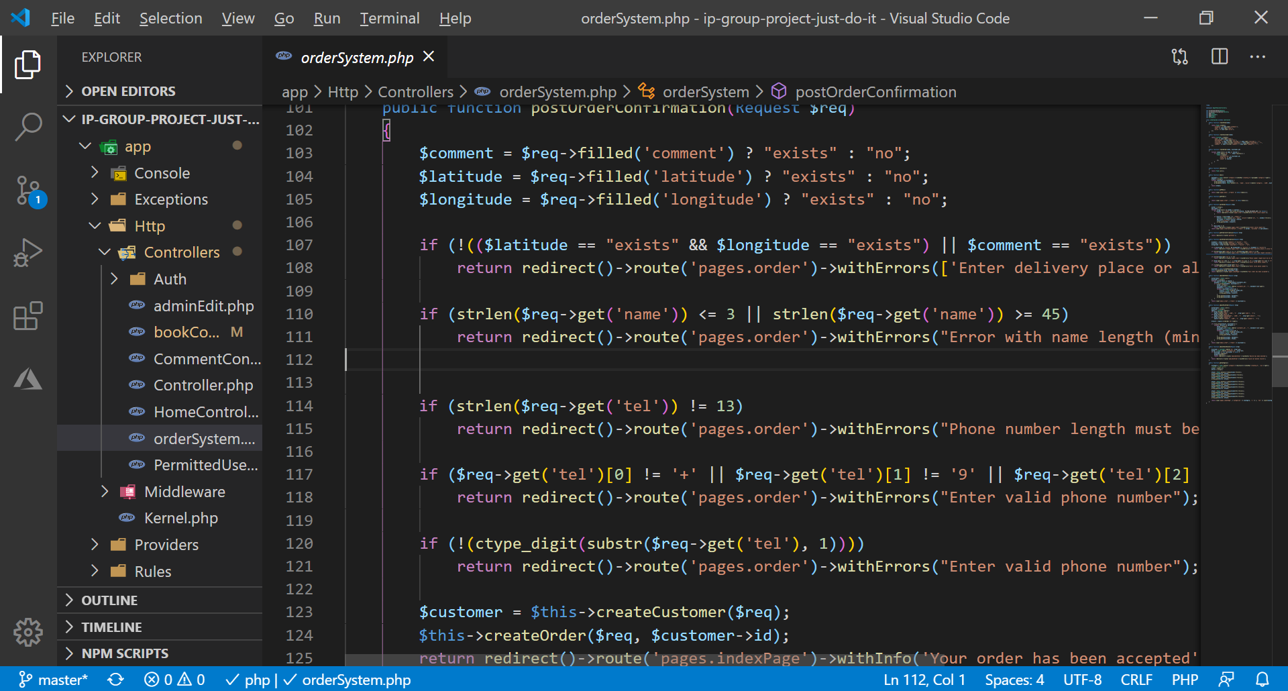

It checks all type of user input validation if any fails it will redirect to order food again. We first wanted to latitude and longitude should exists. But we realized that not all people can turn on this function from browser configuration so we made if latitude and longitude is not provided minimum case is description for location should be passed. Or both should be provided. Also it check name validation and telephone in form +998ABXXXXXXX. Also we took into account cases when user can change html code from browser side and submit to break our server. For this case we have implemented all required validations.

If user submits valid form he/she will see info of accepting:

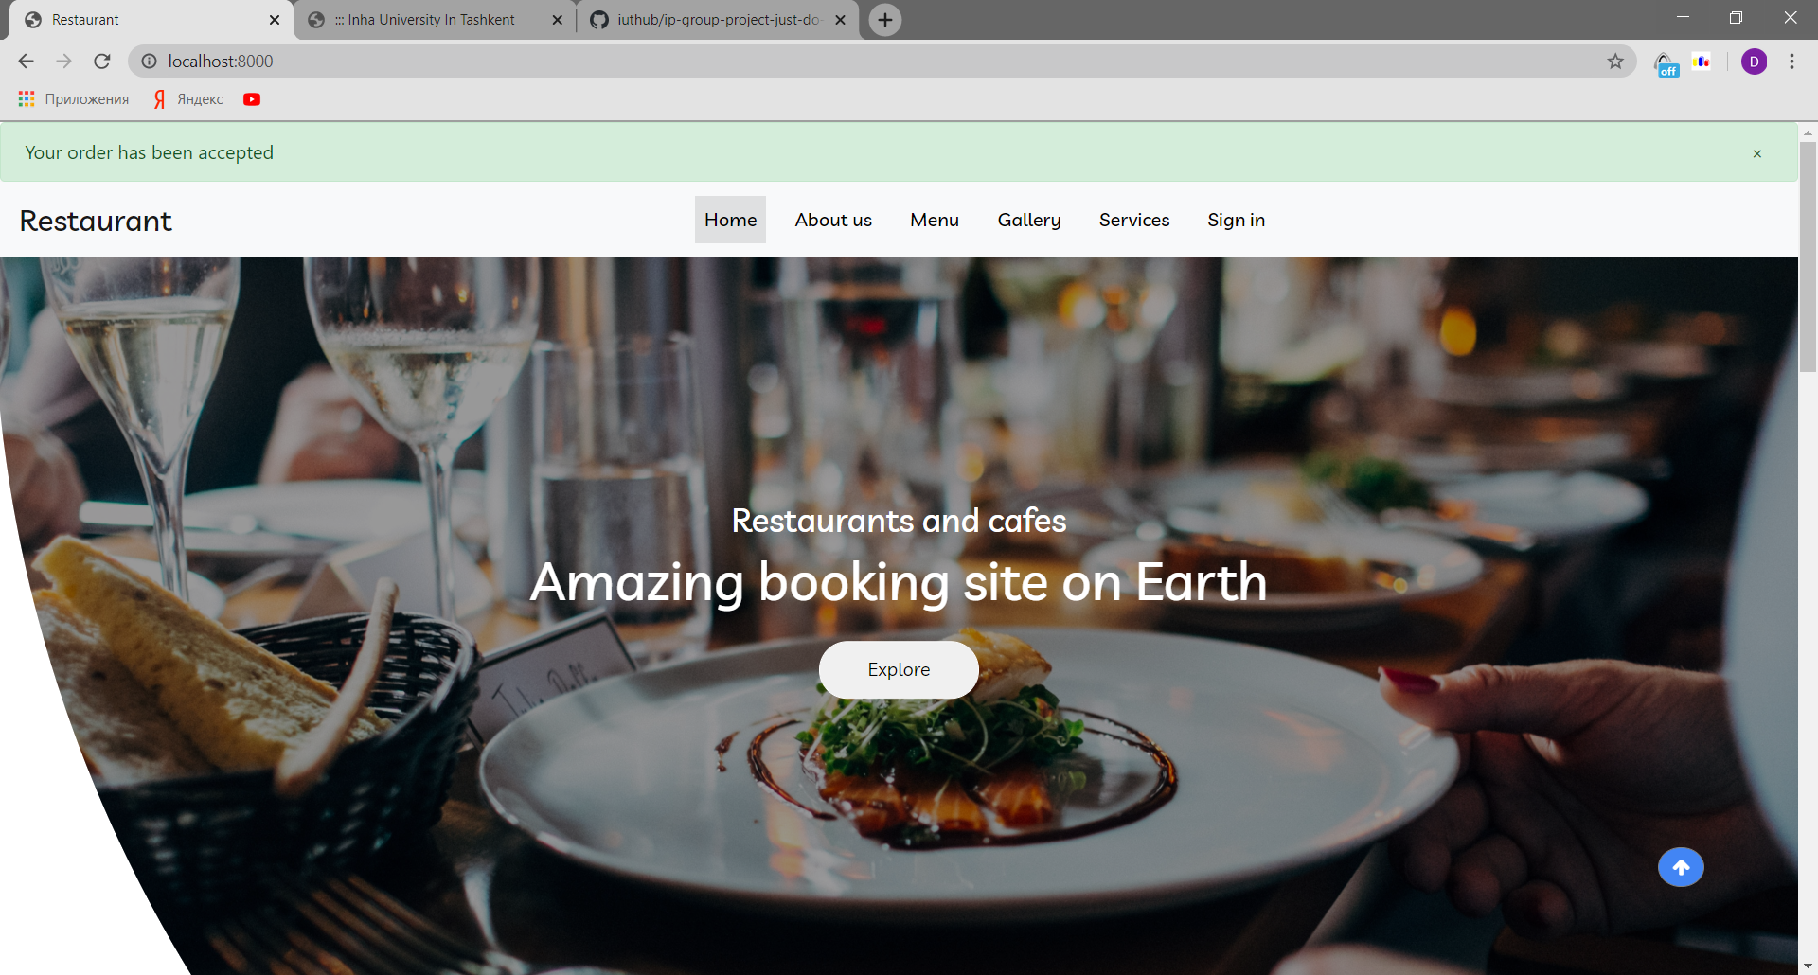

Database migration for orders:

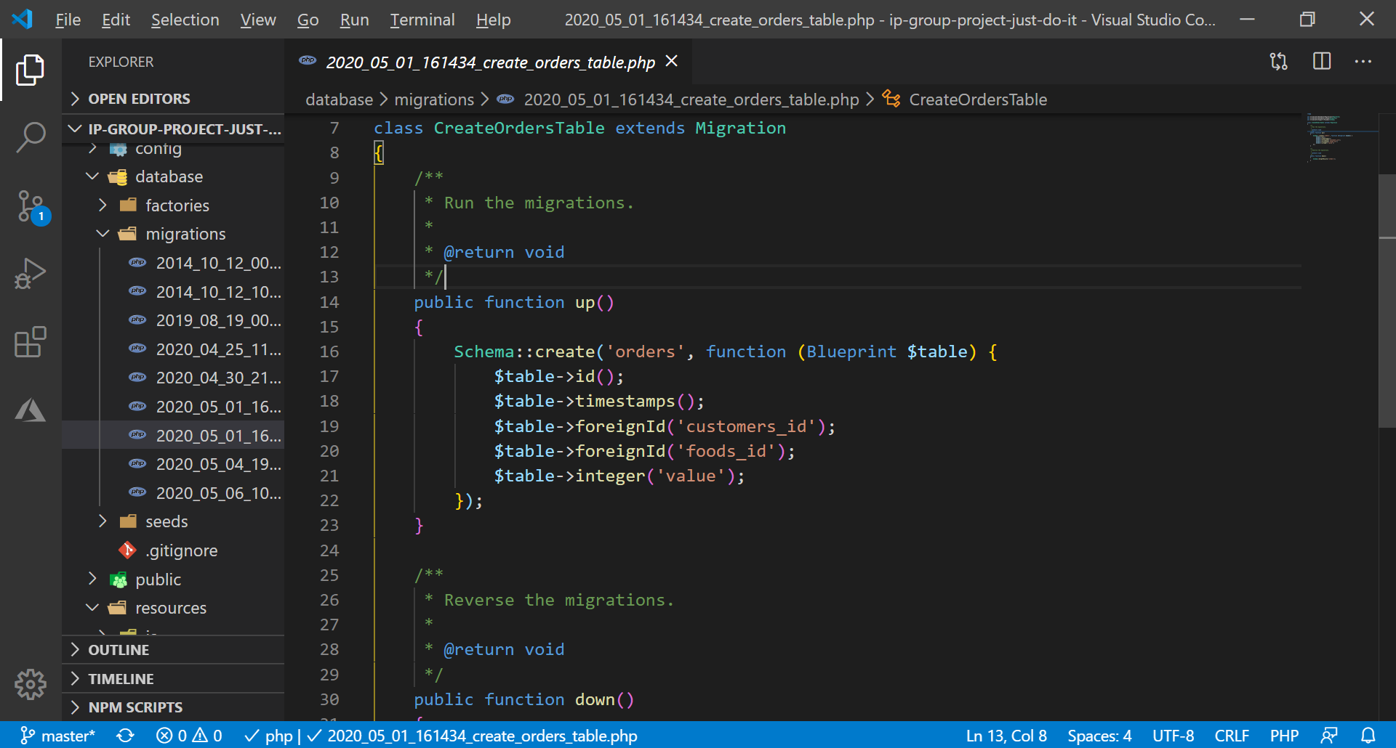

Database migration for customers:

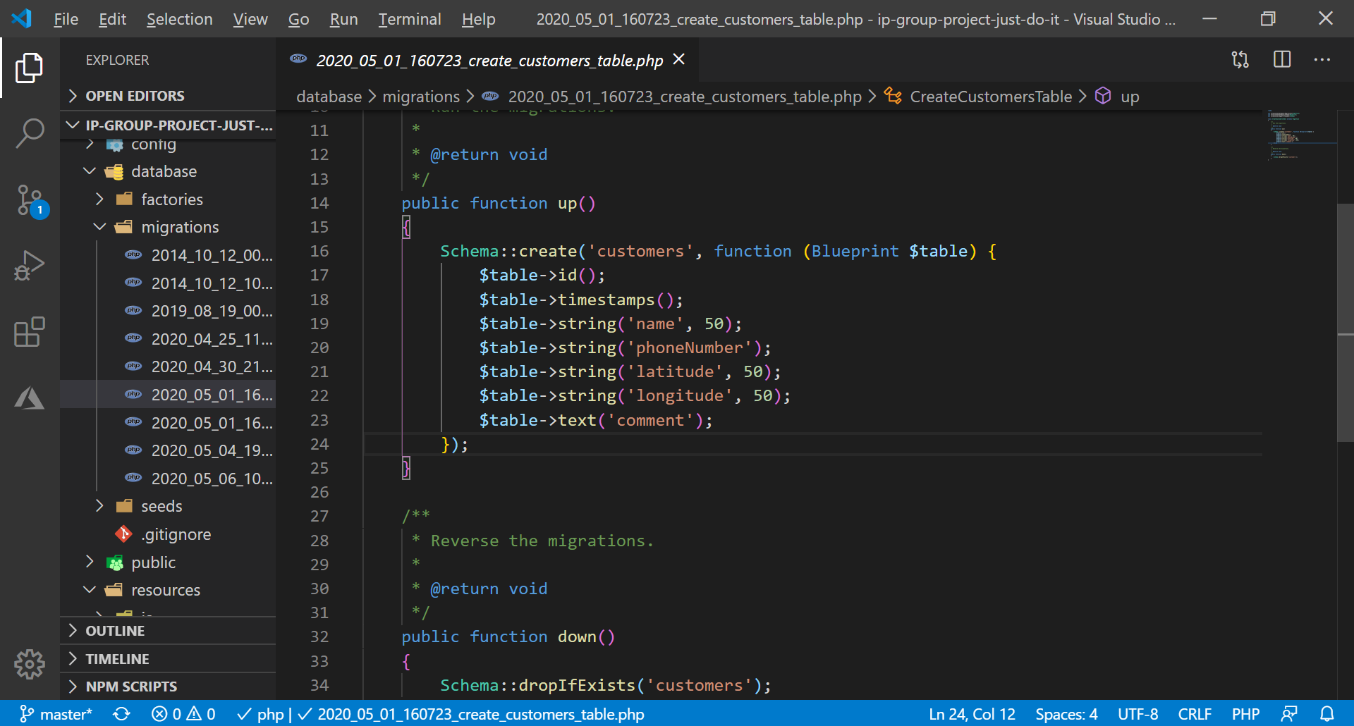

Customers and order table in one-to-one relationship

**Admin page of foods order:**

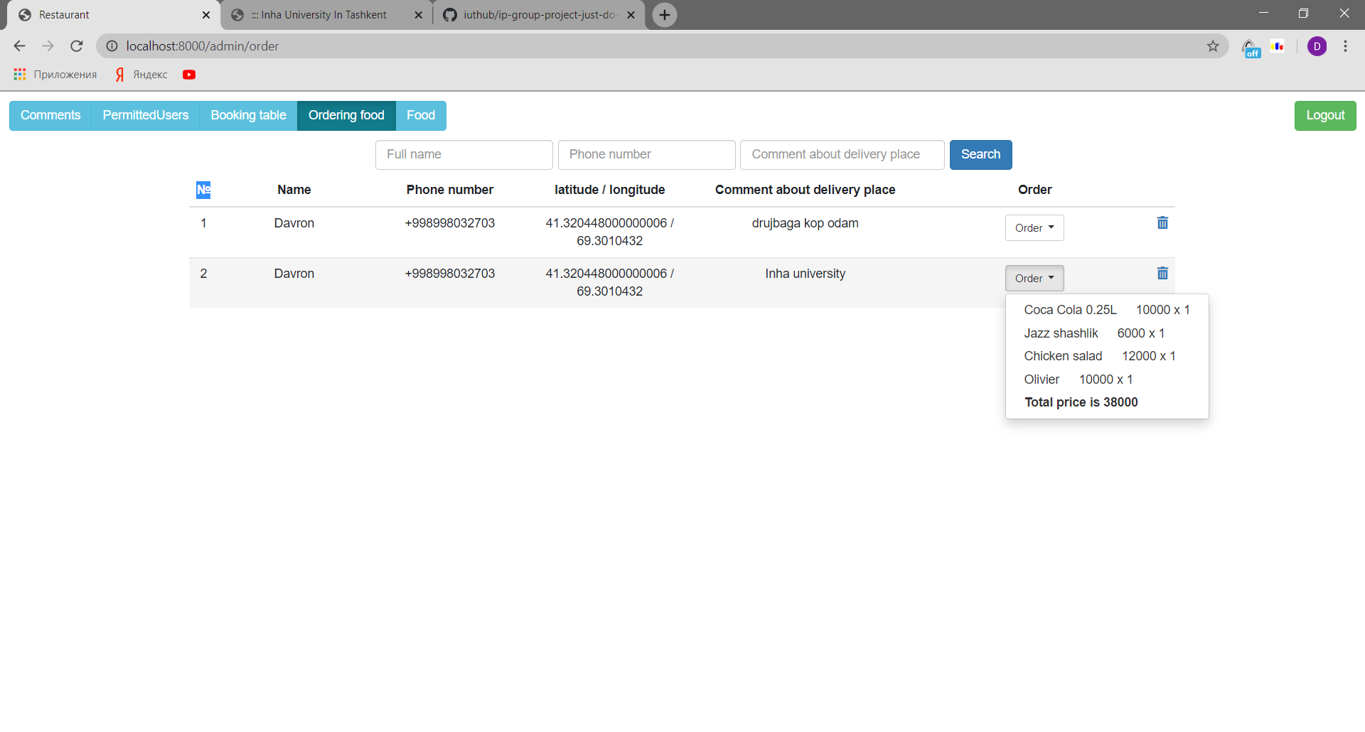

Code how Controller passes data:

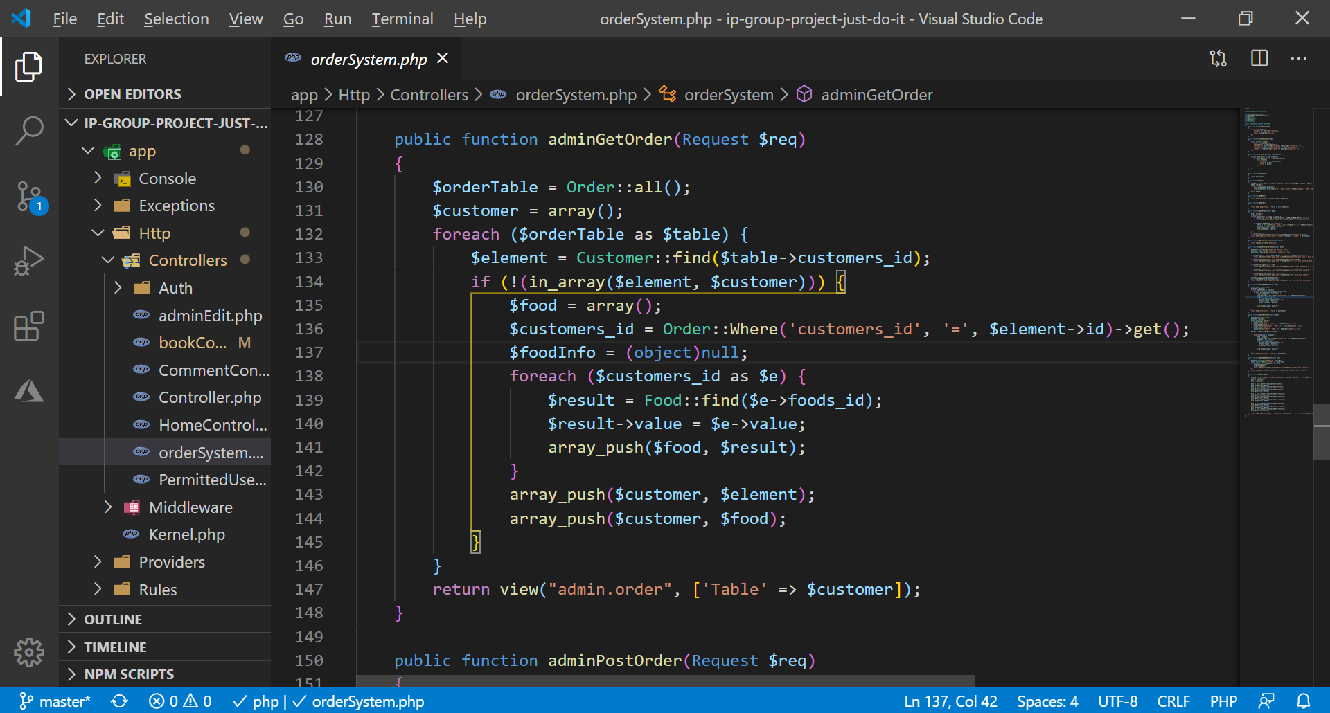

Admin can see all details of orders. Also after delivering it admin can delete order. Here is deletion code:

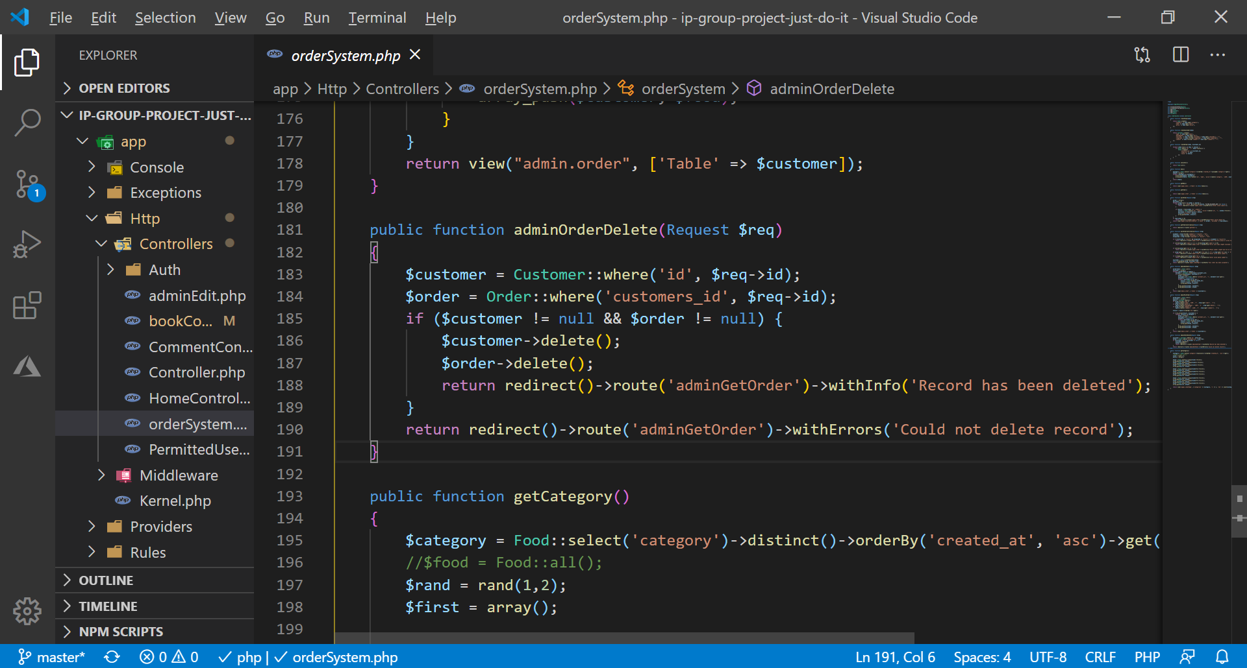

Also admin can search any kind of data partially or fully using names, phone numbers or delivery places(they can be used together or partially):

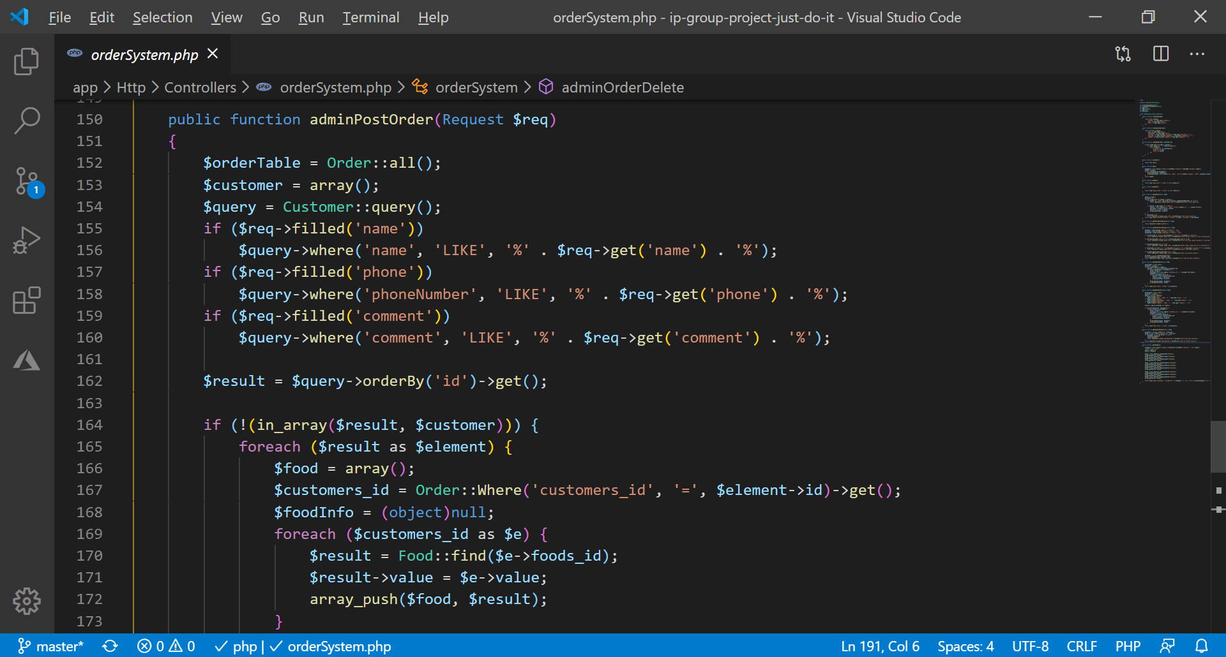 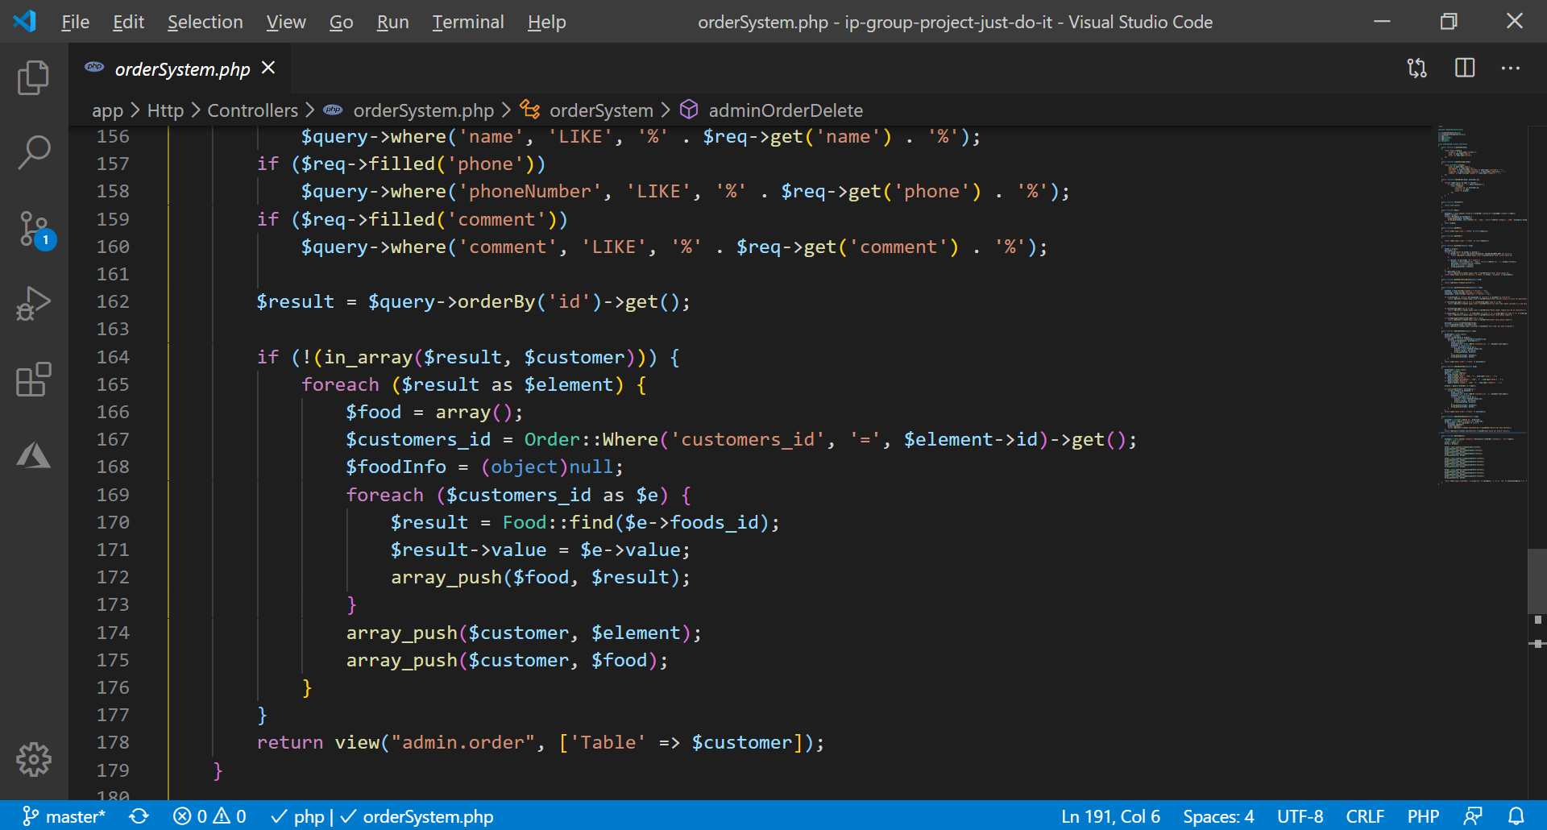

This code illustrates how backend searchs for that.

**Admin add/modify/ delete food pages:**

Add food page for admin:

Admin should choose name, category, price and photo of food in order to add. Image is saved to public->food_img folder.

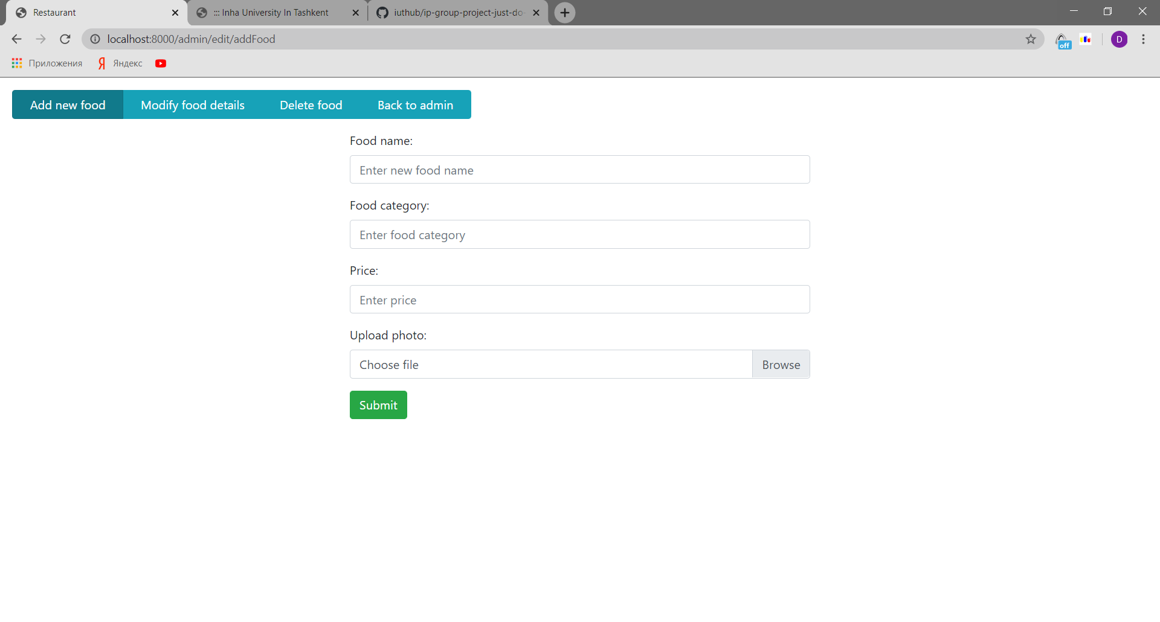

Database schema of food:

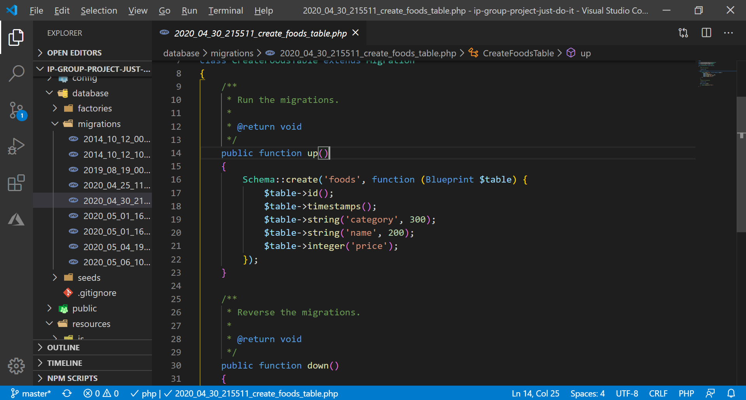

User side validation:

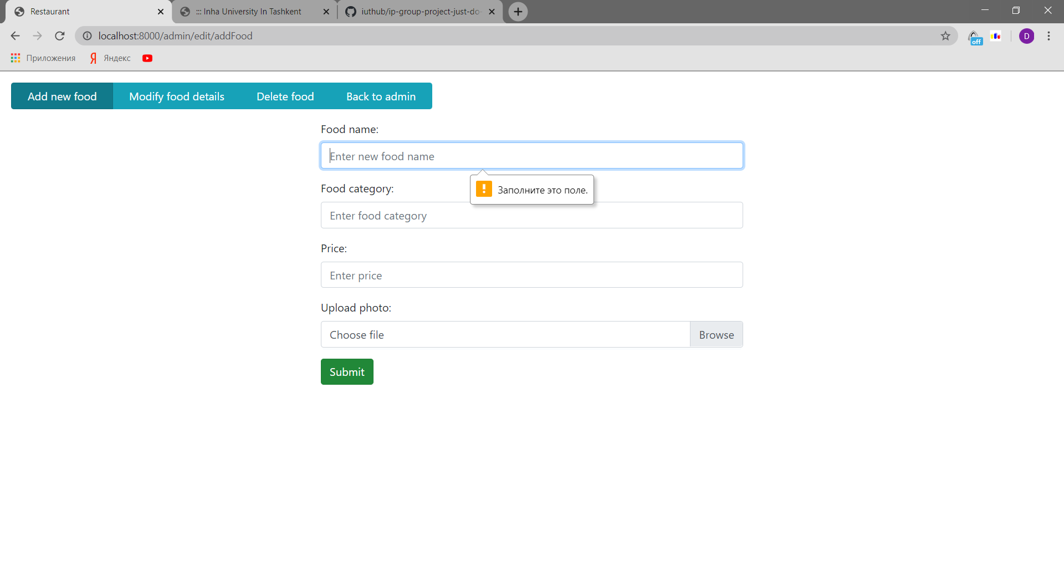

Success message:

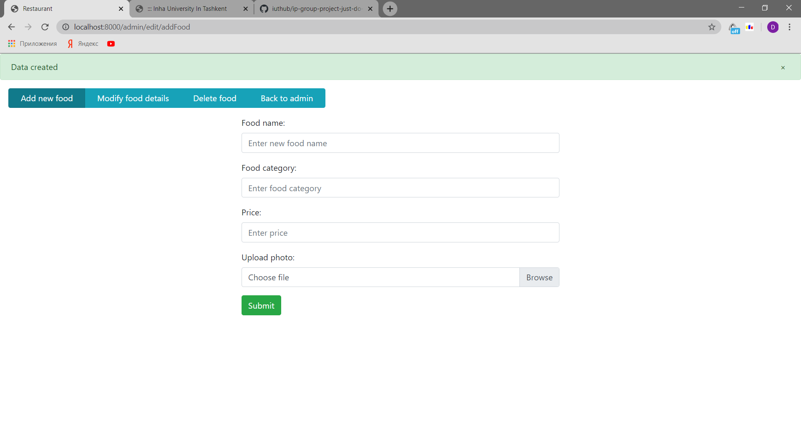

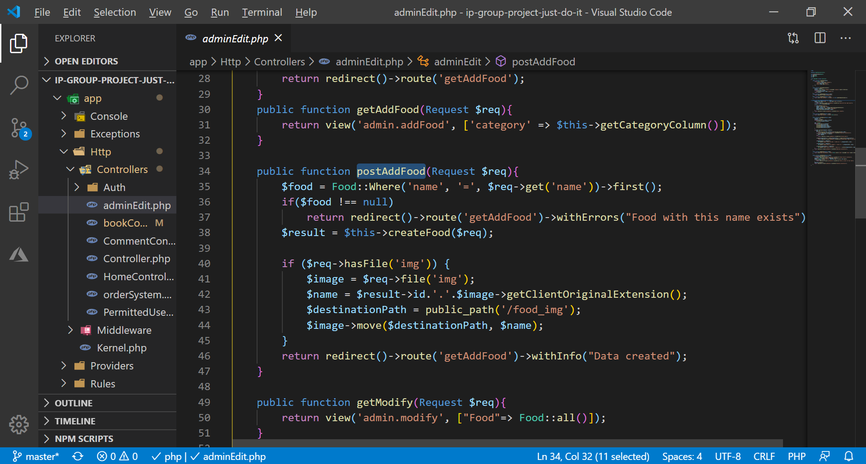

**Admin modifying food page:**

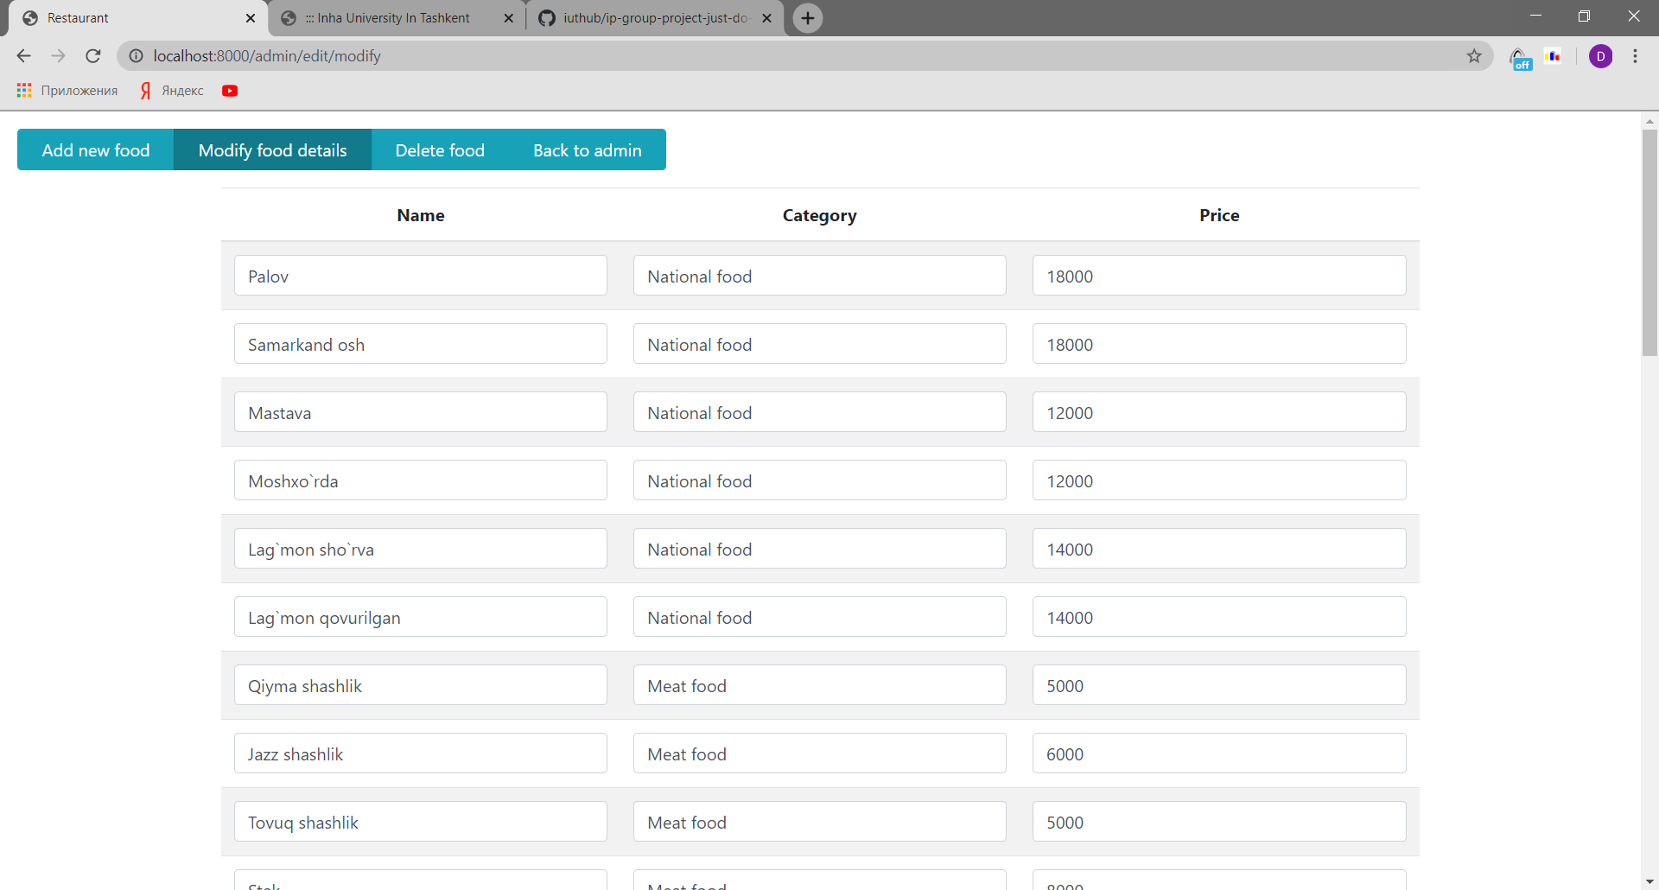

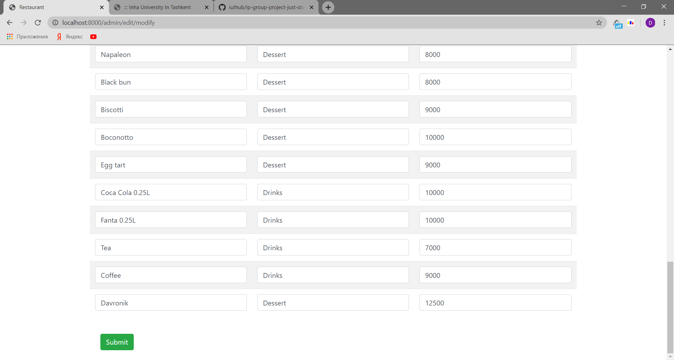

Admin can modify any think and backend functions will change details:

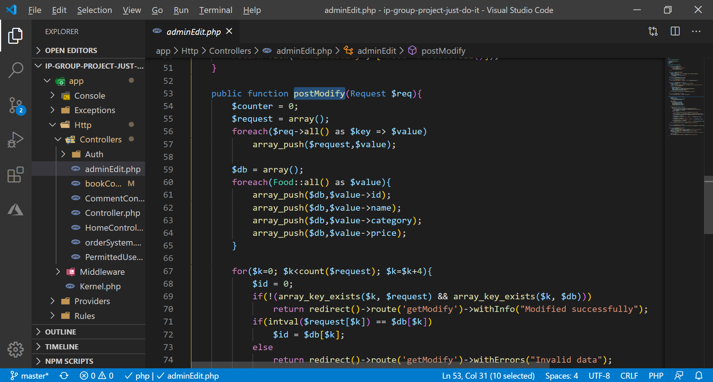

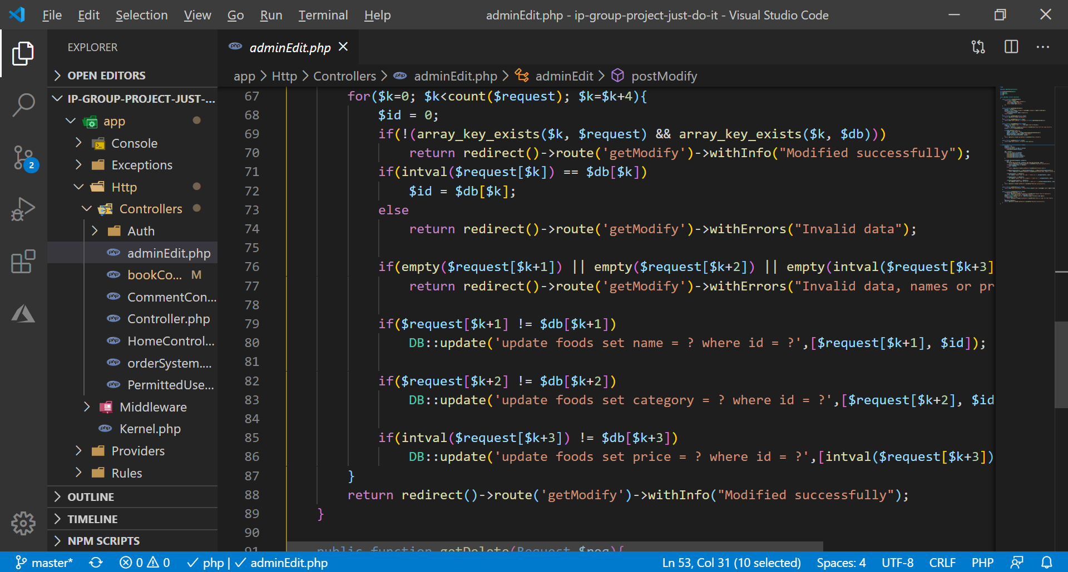

**Admin delete food page:**

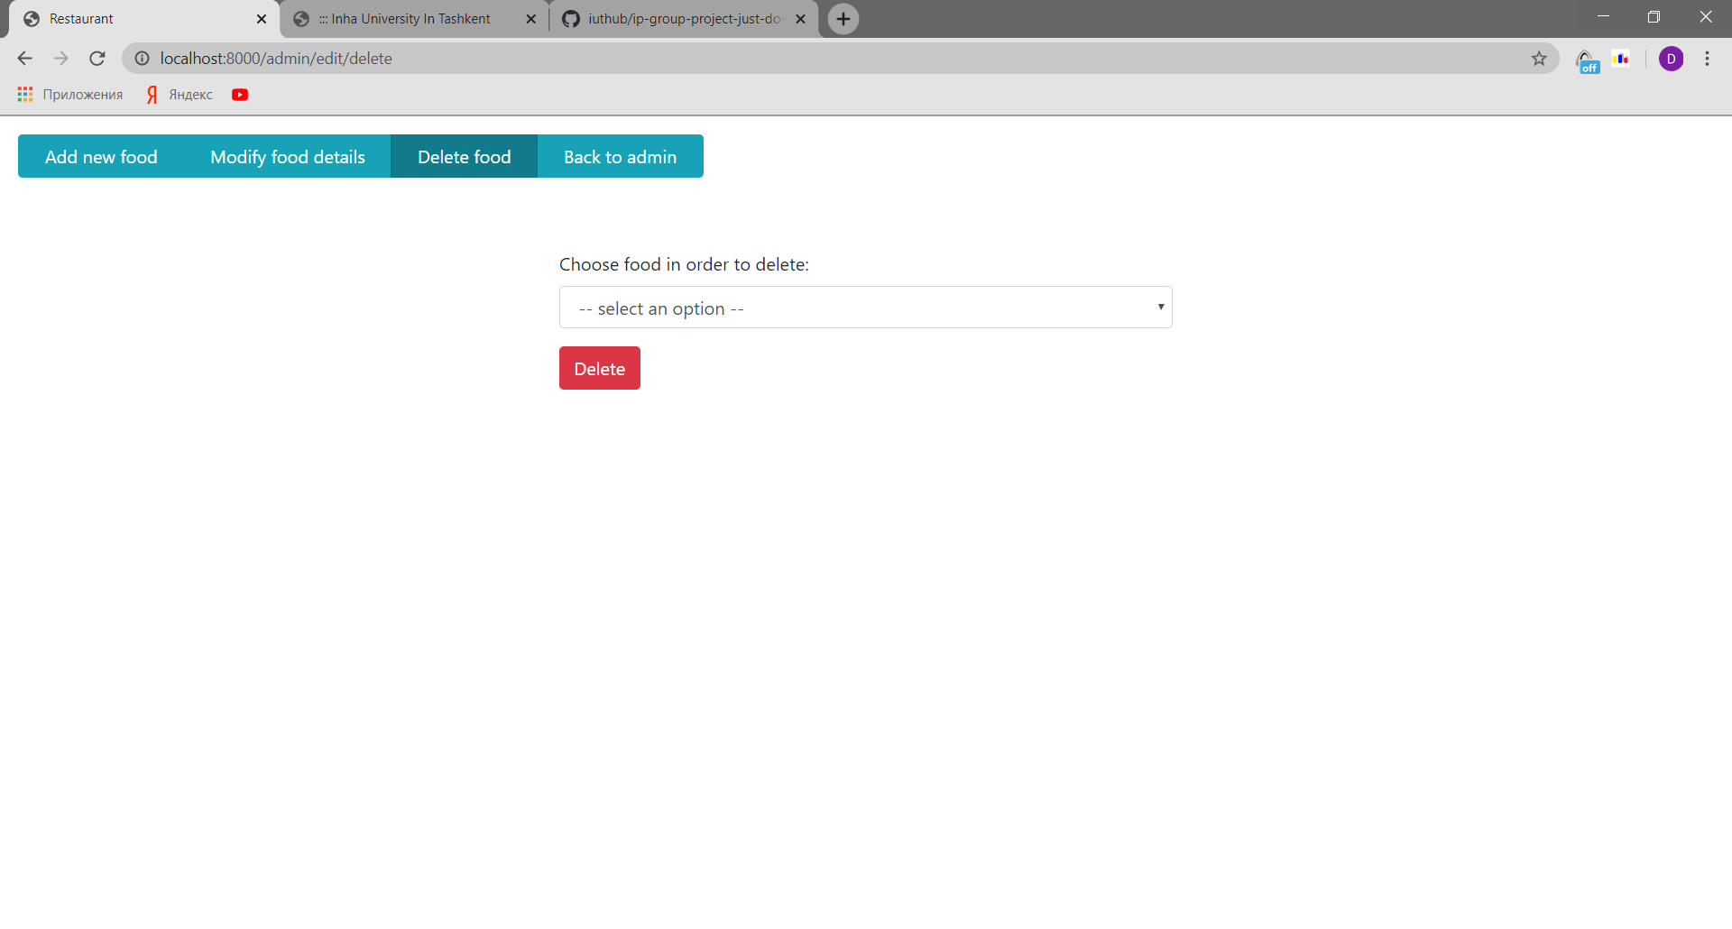

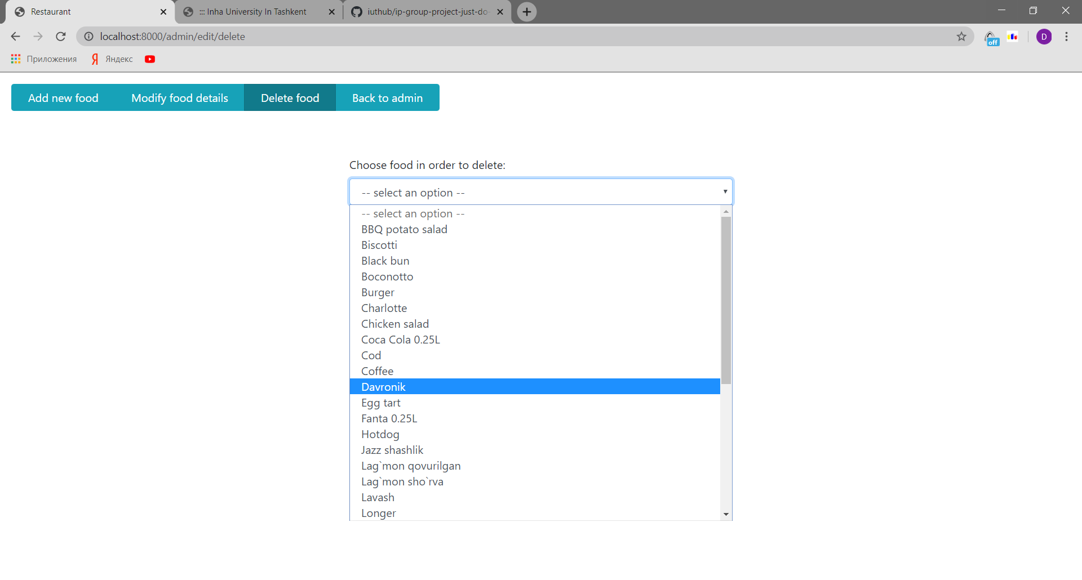

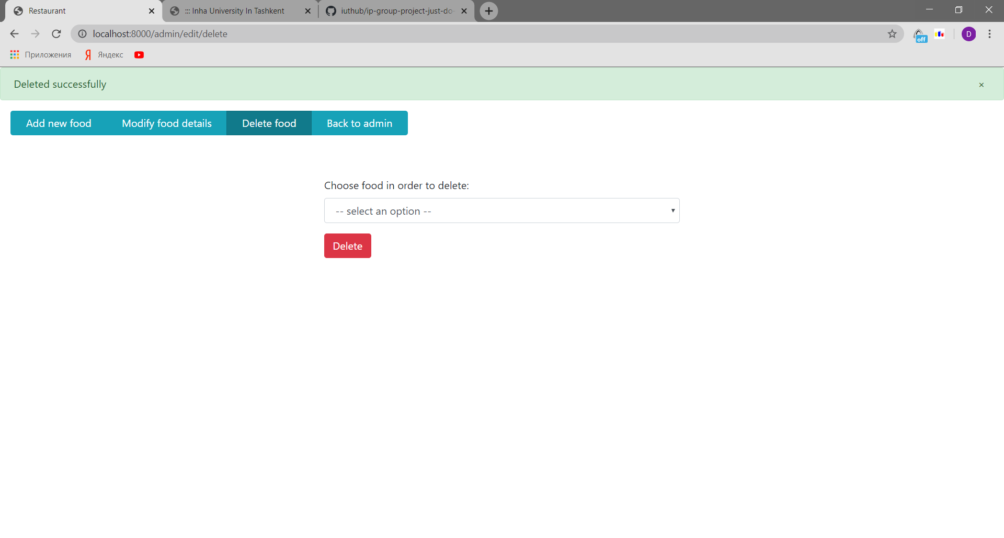

if admin deletes without selection, error will be shown:

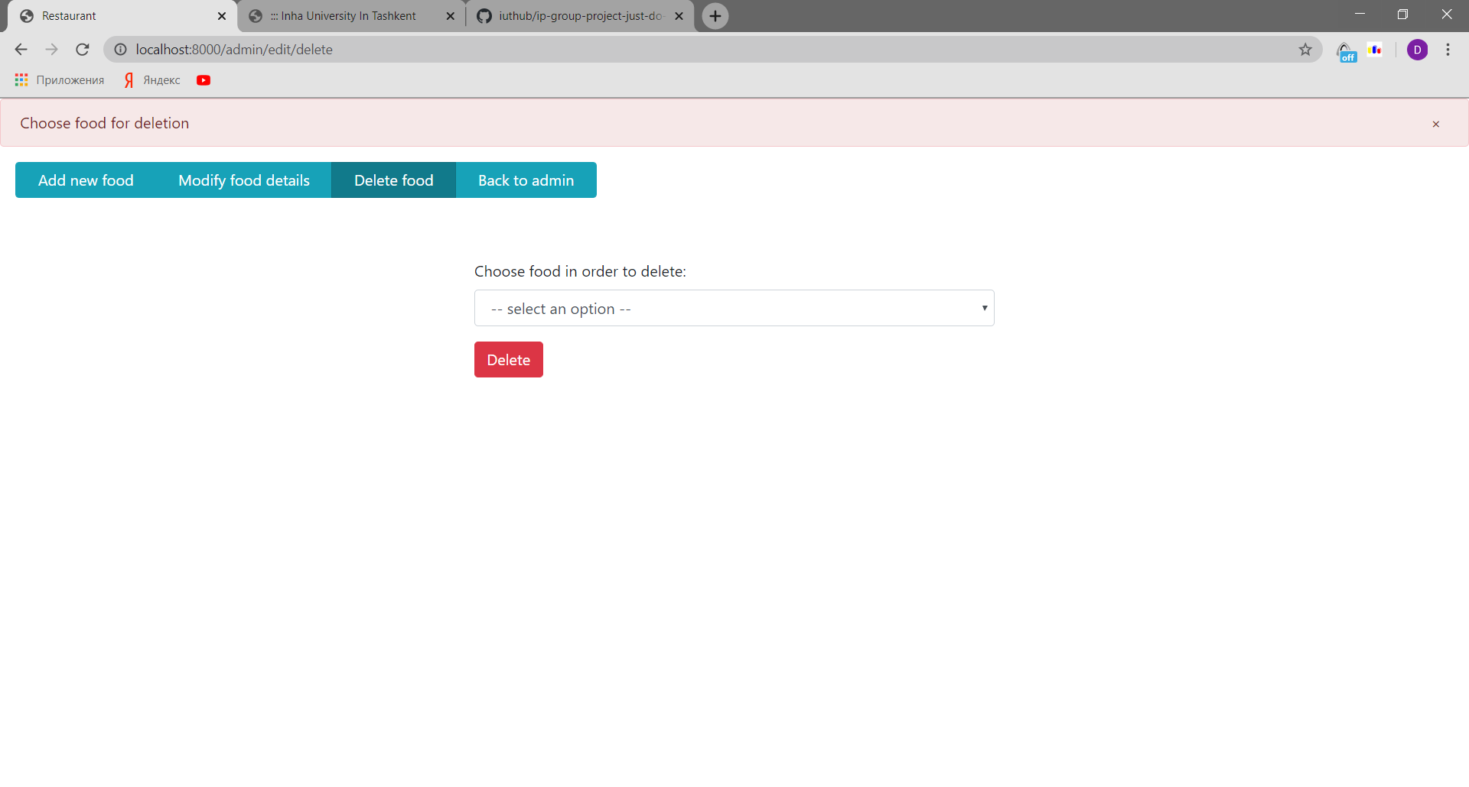

Code:

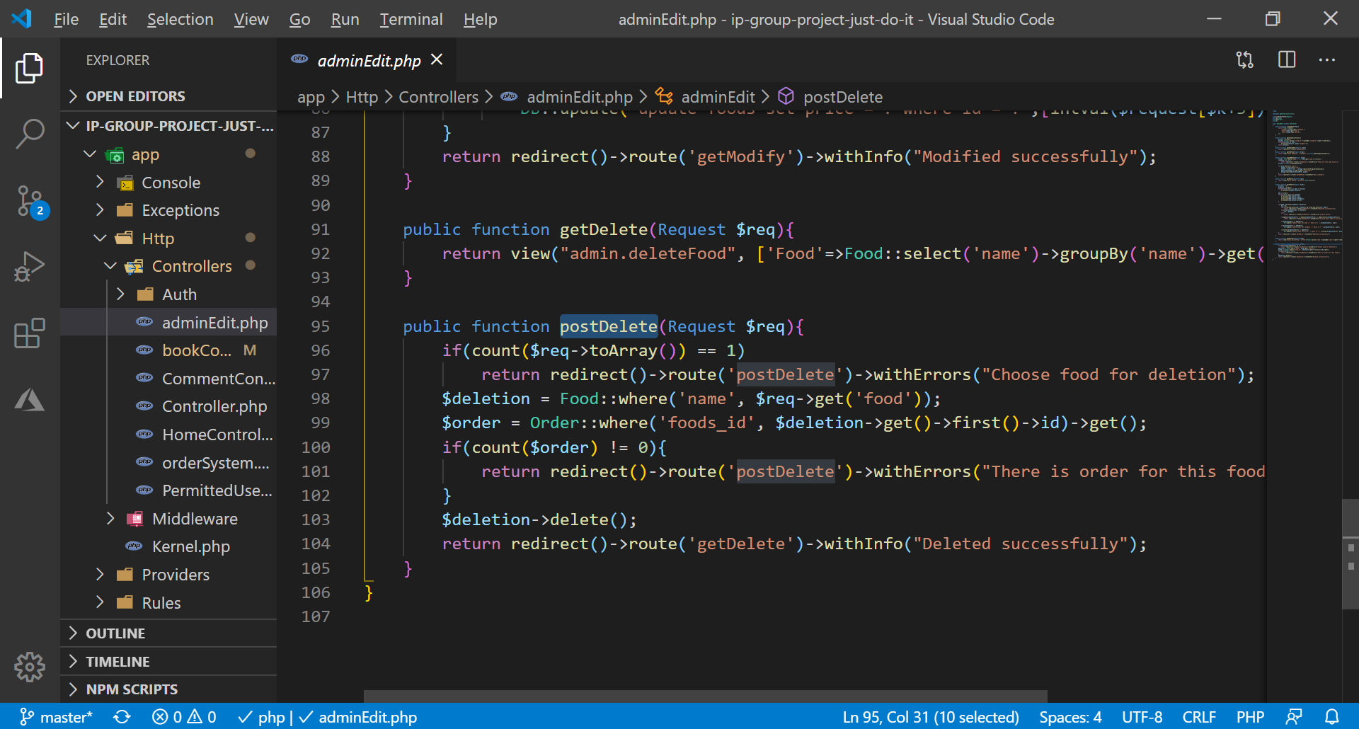

We also checked that if deleting food is has been ordered before than it will not delete end show warning message.

**About and Gallery page:**

Additionally, In this website we made AboutUs.blade.php (partials aboutus.blade.php) and Gallery.blade.php (partials galleryone.blade.php) and AboutUs article page which can user read about our restaurant Article.blade.php For instance pages and we styled using Css namely in public folder for AboutUs.blade.php (aboutpart inside style.css and there are images we used in this website) for Gallery.blade.php (gallerypart inside style.css, animate.css and images we used in this website) Also I made changes in routes in order route these pages correctly and we used Controller functions to show page . By and Large in AboutUs.blade.php we used links from Bootstrap Bootstrapcdn, Font-awesome to style icons, Font namely to style font-family, font-weight, font-size and other styles,and Our own style.css file which I created in public aboutpart and gallerypart folder. In our page Body part We used @include() method to link our friend’s navbar part because He styled home page and he created navbar and footer and We should use for every page same navbar and footer. In This Navbar we used (navbar navbar-expand-lg navbar-light bg-light) classes and social-media icon.

In the same way We created carousel wrapped to build carousel images in website we used classes (carousel slide carousel-fade) which slides to side and fade effect. In style.css we divided row to carousel items to paste several images and carousel –caption to write text about us just as previous and next buttons.

We created another row to paste our content and send our user to article page. In this section We used classes text-center text-lg-left dark-grey-text to make text center, to put text left lg when screen big and color of text grey. In this row we divided in 2 part 1 col for content 2 col for image for image we used z-depth-1-half to make shadow. Also we used img-fluid class for image to make responsive also we used mask class when user hovers on image image color changes After this row we created new row for our customers feedback which is not never changes fixed text In this card image of user and his text.

Additionally we created new row for contact form which can help to our user to leave their feedback about our service and we reply them by email. In this form we created input field for name email text and we created button to submit. This field shows error when user not writes or breaks input require rule. Then we wrote {{ csrf_field() }} for correctly working laravel. Just as we created another col for our info.

Indeed footer we linked by include because our footer same in all page In this footer has map to find us for user and our info part.

At the end we divided in parts our page to make its understandable for developer in Body we cut our code and pasted In partials folder and we linked our body by @include to show our section navbar and footer.

For instance, in Gallery.blade.php we created links for Bootstrapcdn and javascript link and our style.css link as we sad in AboutUs.blade.php in Gallery.blade.php also includes navbar and Body part we created row for image overlay and when user hover on image it changes its color and will appear our gallery text here we used img-fluid makes images responsive and mask class for alter visibility of an element some hiding it. In spite of we created new container for content and it is divided to 2 part 1 for contect about our restaurant places our architecture our guest our events and useful info and this content related with image in this content we used class z-depth-1 to make shadow padding margin dark text text-lg-left d-flex creates flexbox content align-items-center to make items center font-weight-bold for make letter bold text-muted for image img-fluid , since we created a lot of similar content section similar to this because I gave info about our gallery.

In AboutUs.blade.php we linked to Article.blade.php and In this Article.blade.php user can read a lot of news and text about our restaurant In this page we linked to Bootstrapcdn and style.css

We created new container and inside we created div p – and pasted a lot of article about us after we created figure due to insert image we used img-fluid and z-depth-1 just as figure caption to write words. As we continued to write text about us At the end we made button to go back.

Same in Gallery page divided to parts as body we located in partials folder and linked by @include to show our content navbar and footer. In routes we created Route and get method to get page fuction for return our page For AboutUs page we used Post method to return our page.

AboutUs page

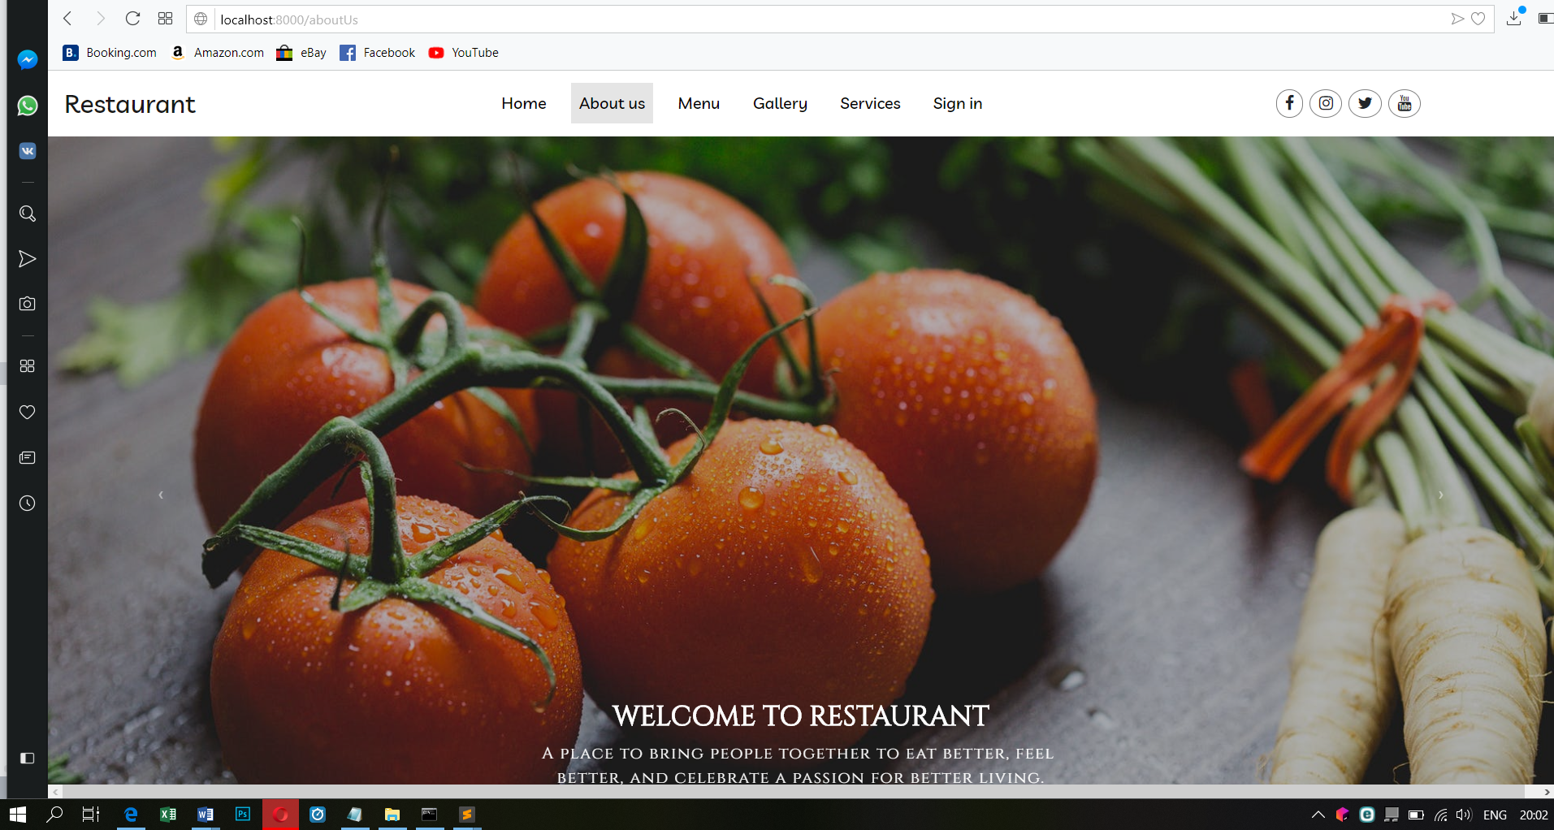

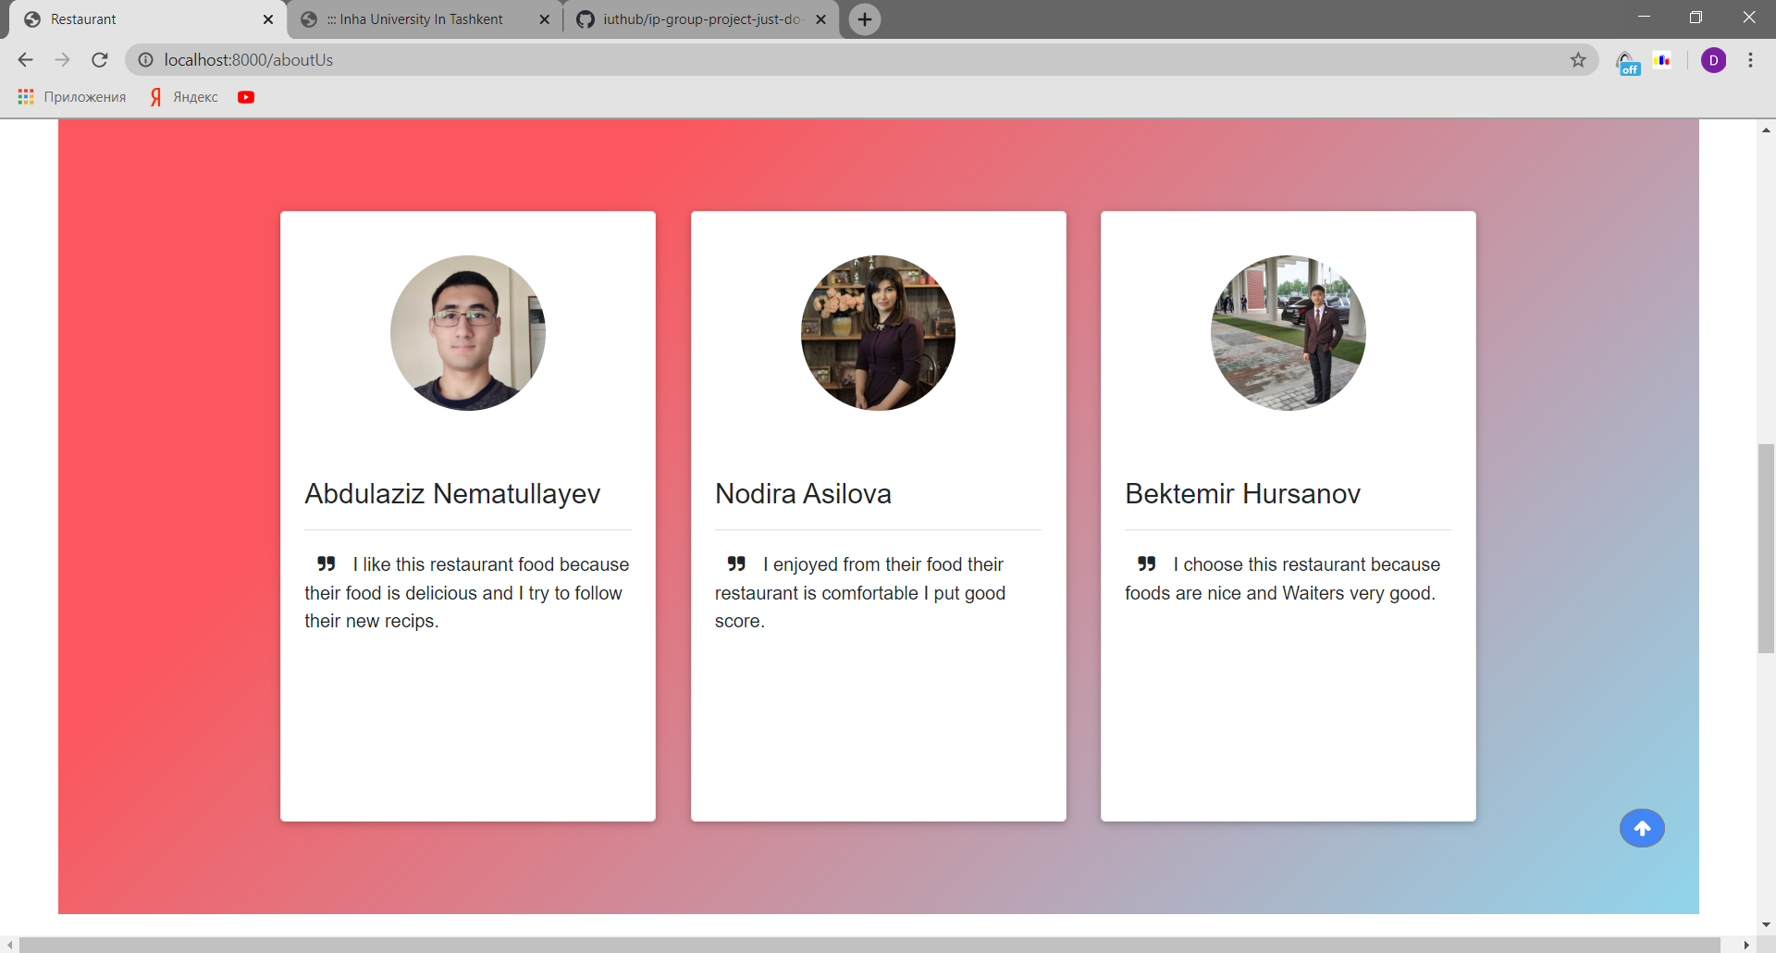

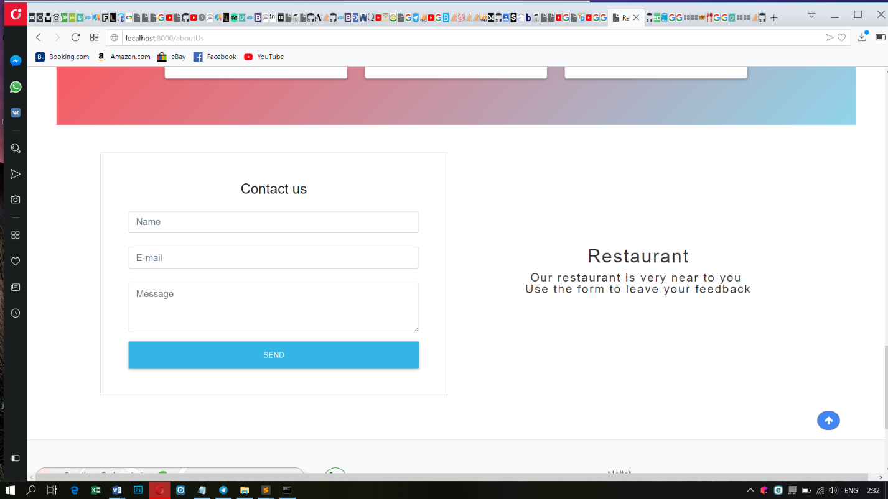

**Gallery page:**

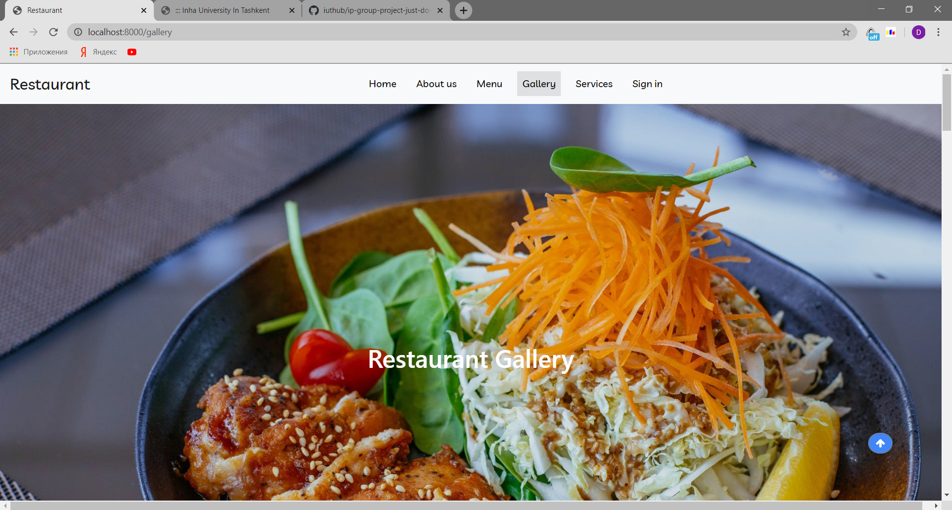

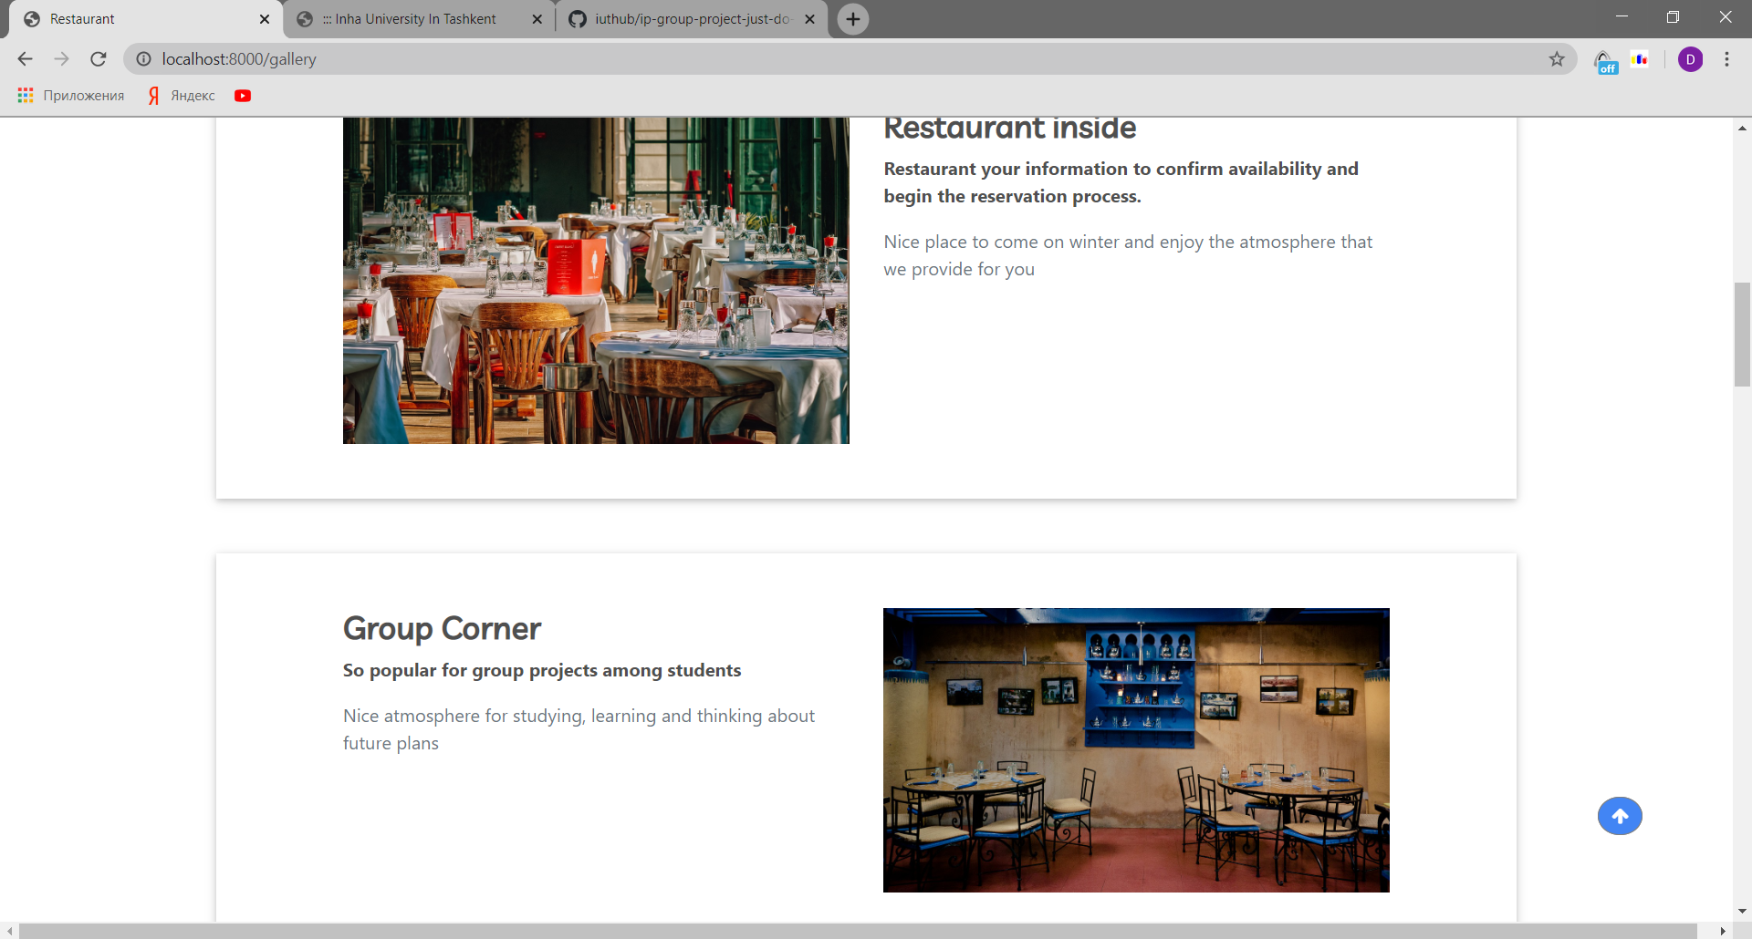

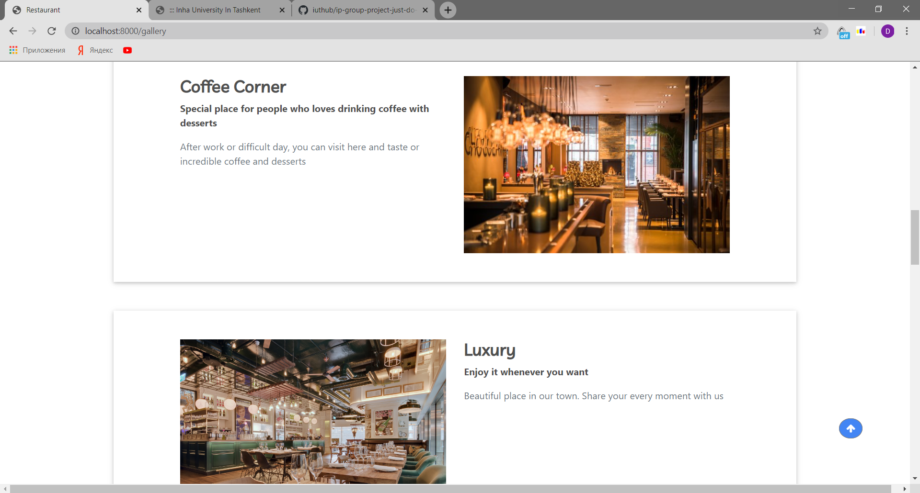

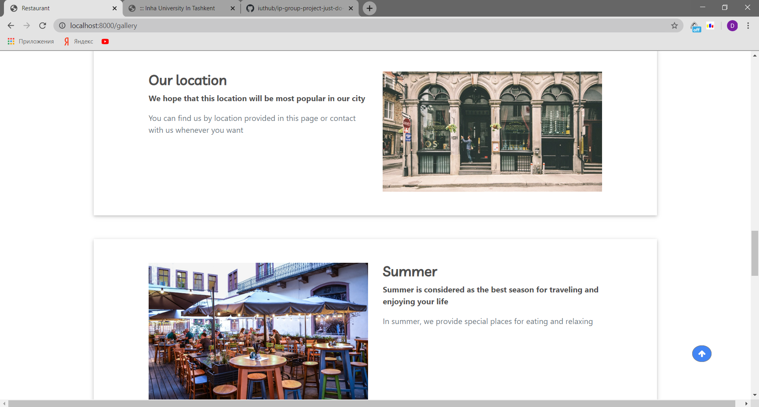

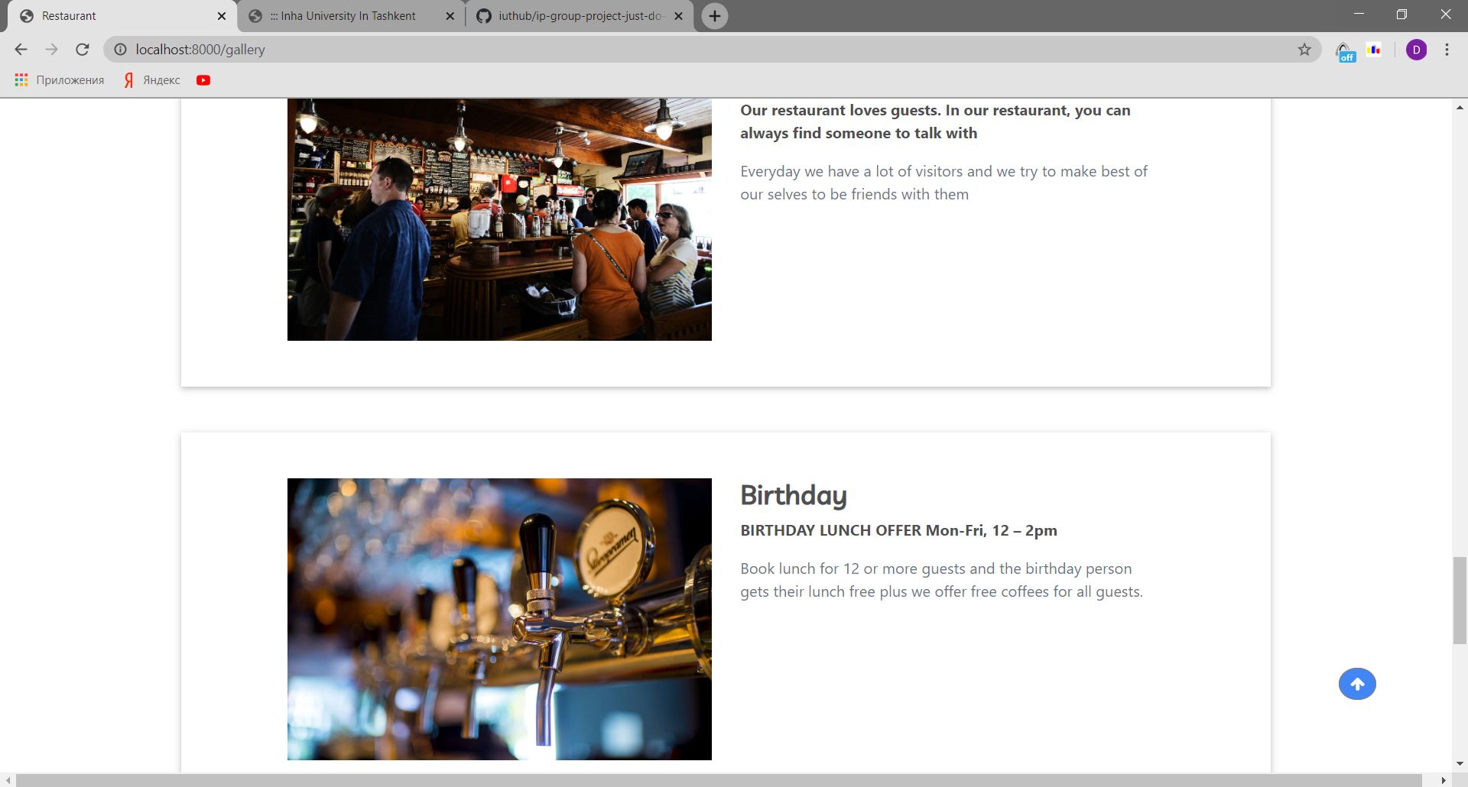

**Each user contribution to project:**

Tursunov Davronbek U1810147

Designed backend using laravel. Backend side of admin Add food/ modify food/ delete food/ Order list also backend side of Menu and Delivery System. Database: Foods, Customers and Orders

Kodirov Tokhirjon U1810163

Designed backend using laravel. Backend side of admin feedback list/ Booked tables list and Login/logout admin/user. Also Booking table system backend. Database: book and commets

Jamshid Tursunov U1810153

As a front-end developer, created and designed front end part of main page fully, helped to others for fixing bug

Shahzod Buriev U1810084

As a front-end developer, created and designed front end part of menu and order page, helped to others for fixing bug

Zufarov Sardor U1810172

As a front-end developer, created and designed front end part of gallery and aboutUS page, helped to others for fixing bug

Ulugbek Ulugbekov U1810192

As a front-end developer, helped to others for fixing bug

Default logins:

After running php artisan migrate:refresh –seed

Register with any following mail:

[d.tursunov@student.inha.uz](mailto:d.tursunov@student.inha.uz)

s.zufarov@student.inha.uz

[t.kodirov2@student.inha.uz](mailto:t.kodirov2@student.inha.uz)

[j.tursunov@student.inha.uz](mailto:j.tursunov@student.inha.uz)

[s.buriev@student.inha.uz](mailto:s.buriev@student.inha.uz)

[u.ulugbekov@student.inha.uz](mailto:u.ulugbekov@student.inha.uz)

Maybe if I register before you Professor:

Davron

12345